**Sieyuan Electric Co., Ltd.**

**2023 Sustainable Development Report**

**v2.3**

Table of Contents

[About the Report 3](#_Toc192495136)

[Reporting Period 3](#_Toc192495137)

[Reporting Boundary 3](#_Toc192495138)

[Reference Standards 3](#_Toc192495139)

[Data Sources 3](#_Toc192495140)

[Designations 3](#_Toc192495141)

[Access to the Report 3](#_Toc192495142)

[Message from the Chairman 4](#_Toc192495143)

[1. About Sieyuan 6](#_Toc192495144)

[1.1 Company Overview 6](#_Toc192495145)

[1.2 Organizational Structure 7](#_Toc192495146)

[1.3 Corporate Culture 8](#_Toc192495147)

[1.4 Honors 8](#_Toc192495148)

[2. Social Responsibility Management 11](#_Toc192495149)

[2.1. EHS Policies 11](#_Toc192495150)

[2.2 Social Responsibility System 11](#_Toc192495151)

[2.3 Communication with Stakeholders 11](#_Toc192495152)

[2.4 Analysis of Material Topics 13](#_Toc192495153)

[3. Long-term Planning to Maintain Prudent Operation 14](#_Toc192495154)

[3.1 Governance Structure 14](#_Toc192495155)

[3.2 Internal Control System 15](#_Toc192495156)

[3.3 Compliant Business Operation 15](#_Toc192495157)

[3.4 Business Ethics 16](#_Toc192495158)

[3.5 Information Security and Privacy Protection 17](#_Toc192495159)

[3.6 Information Disclosure 18](#_Toc192495160)

[4. Win-Win Cooperation to Grow Together 19](#_Toc192495161)

[4.1 Innovation-driven Development 19](#_Toc192495162)

[4.2 Product Quality 21](#_Toc192495163)

[4.3 Customer Services 25](#_Toc192495164)

[4.4 Sustainable Supply Chain 26](#_Toc192495165)

[4.5 Industry Cooperation 28](#_Toc192495166)

[Case Study: Sieyuan Electric exhibited multiple energy storage products at the 2nd International Energy Storage Conference. 28](#_Toc192495167)

[5. Employee Empowerment to Inspire Their Potential 31](#_Toc192495168)

[5.1 Compliant Employment 31](#_Toc192495169)

[5.2 Employees’ Rights and Benefits 33](#_Toc192495170)

[5.3 Employee Care 34](#_Toc192495171)

[5.4. Employee Development 38](#_Toc192495172)

[5.5 Occupational Health and Safety 39](#_Toc192495173)

[6. Low-carbon Operation to Practice Environmental Protection 44](#_Toc192495174)

[6.1 Environmental System Construction 44](#_Toc192495175)

[6.2 Energy Conservation and Consumption Reduction 46](#_Toc192495176)

[6.3 Pollution Reduction and Efficiency Enhancement 47](#_Toc192495177)

[6.4 Green Operation 48](#_Toc192495178)

[7. Responsibility Bearing to Contribute to Society 52](#_Toc192495179)

[7.1 Educational Support 52](#_Toc192495180)

[7.2 Public Welfare Activities 53](#_Toc192495181)

[8. GRI Indicator Index 54](#_Toc192495182)

[9. SDGs Indicator Index 61](#_Toc192495183)

# About the Report

The Report represents the 2023 Sustainable Development Report (hereinafter referred to as “the Report”) issued by Sieyuan Electric Co., Ltd. (hereinafter referred to as “Sieyuan Electric”) to systematically disclose to its concepts, management, initiatives and achievements in sustainable development in 2023.

## Reporting Period

The Report covers the period from January 1 to December 31, 2023, and may refer to the information of other years for reasons of project continuity or significant impact.

## Reporting Boundary

The Report encompasses the complete business operations of Sieyuan Electric and its subsidiaries, including the Company's corporate sustainability concepts, strategic initiatives, practical implementations, and operational performance during the reporting period.

## Reference Standards

The Report is based on the requirements of *GRI Sustainability Reporting Standards* (GRI Standards 2021) released by the Global Sustainability Standards Board (GSSB) and the United Nations Sustainable Development Goals (UN SDGs).

## Data Sources

The data presented in the Report is extracted from official documents and statistical data of the Company. Unless otherwise stated, the data in the Report are measured in metric system and the currency is denominated in Chinese Yuan (CNY). Should there be any discrepancies with the financial statements, the latter shall prevail.

## Designations

To facilitate this presentation, Sieyuan Electric Co., Ltd. is expressed as "Sieyuan Electric", "Sieyuan", "the Company” or "we" in the Report, unless otherwise specified herein.

## Access to the Report

This report is available in paper and electronic form. To obtain the electronic version of the Report or have any questions or suggestions regarding its contents, please call or email to us.

Address: No. 3399, Huaning Road, Minhang District, Shanghai, China

Postal Code: 201108

Tel.: 021-61610502

Fax: 021-61610900

E-mail: webmaster@sieyuan.com

Website: www.sieyuan.com

# Message from the Chairman

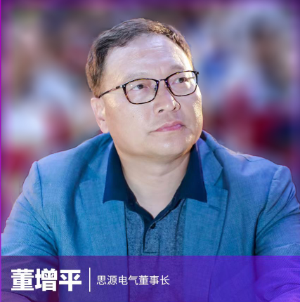Since its establishment, Sieyuan Electric has always adhered to the mission of "Smarter Power, Better Life", and is committed to becoming a global leader in the electrical industry. In 2023, we initiated the construction of new power systems and accelerated their applications. We optimize resource allocation, continuously innovate and enrich existing products, and focus on high-quality development. Moreover, we actively fulfill our environmental, social and governance responsibilities, and integrate the ESG concepts into our development strategies, production, operation and corporate culture. We constantly strengthen our sustainable development capabilities, and endeavor to realize the coordination and harmonization of corporate development with employee growth, ecological and environmental protection, and social harmony.

Dong Zengping

Chairman of Sieyuan Electric

**This year, we implemented lean corporate governance and laid a solid foundation for our development.** We stand for the value of integrity and honesty, vigorously strengthen the implementation of compliance systems, and constantly improve the internal control system to prevent business risks. We abide by business ethics, improve the anti-corruption management institutions, and uphold fair competition. We strictly fulfill the obligation of information disclosure, properly deal with investor relations, actively return investors, and safeguard the legitimate rights and interests of shareholders.

**This year, we adhered to innovation-driven development and optimized the core engine.** We make great efforts to promote and improve Sieyuan's integrated product development system, and constantly increase investment in scientific research, accelerating the breakthroughs in key technologies and forming a platform-based economy of scale. We take great pains to talent training and industry-academia-research collaboration with well-known universities such as Tsinghua University, Shanghai Jiao Tong University, Xi'an Jiaotong University, Huazhong University of Science and Technology, North China Electric Power University, Hunan University and Southwest Jiaotong University, to boost the performance of innovation system.

**This year, we strove to achieve the carbon peak and neutrality targets and further drive green development.** We incorporate the carbon peak and neutrality targets into the Company's development trend and planning, and gradually apply the digital operation tools throughout the construction of each new manufacturing base, so as to improve management efficiency and energy efficiency and progressively move towards green and intelligent manufacturing. We apply the concepts and methods of circular economy into corporate development and construction, production process, product marketing, etc., to achieve energy conservation, emission reduction, efficiency improvement, quality assurance, and circular sustainability.

**This year, we insisted on the people-oriented law and strove to develop a harmonious enterprise.** We always take the principle of compliant employment, protect the rights and interests of employees by law, advocate humanistic care, and exert the cohesive force of excellent corporate culture. We establish a safety and environmental responsibility assessment system to effectively protect the occupational health and safety of employees. We attach importance to employee development, improve employee training system, and provide employees with smooth career development channels, allowing them to grow and develop healthily, achieving win-win development between employees and the Company, and continuously improving staff's sense of belonging and happiness.

**This year, we strengthened our commitment to serving the people and enhancing their well-being.** We actively practice corporate social responsibility, give back to society through our domestic and overseas branches, and carry out consistently public welfare activities such as donations for education, voluntary blood donation, employment of the disabled and volunteer service. We are intended to constantly improve the well-being of local communities and contribute to the construction of a beautiful and harmonious society.

**After making a good start, we should ensure that the cause achieves fruition.** We will continue to uphold the concept of sustainable development, further promote the deep integration of ESG and corporate development, and continuously create value for enterprises and society. We will maintain the spirit of continuous struggle and positive progress, work together with all stakeholders to promote Sieyuan Electric to become a world-class company, and contribute to China's modernization.

# 1. About Sieyuan

## 1.1 Company Overview

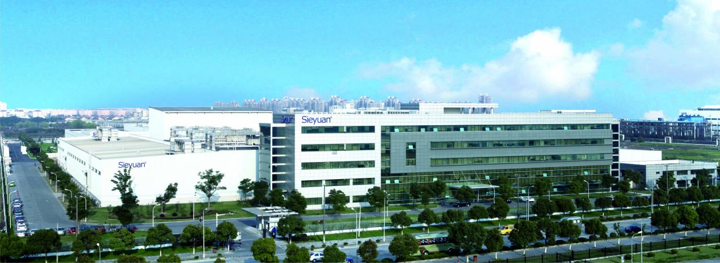

Sieyuan Electric Co., Ltd. was established in December 1993, restructured into a joint stock limited company by approval on December 28, 2000, and listed on Shenzhen Stock Exchange on August 5, 2004 (stock code 002028).

Sieyuan Electric is a well-known listed company in China, specializing in power technology research and development, equipment manufacturing, and engineering services. It has been honored as Key High-tech Enterprises of China Torch Program, China Top Ten Private Enterprises in Energy Equipment, High-Tech Enterprise, Shanghai Innovative Enterprise, etc.

As increasingly expansion of industrial chain, Sieyuan Electric has more than 10 manufacturing entities located in Shanghai, Rugao, Changzhou, Nanjing, etc. Its products include EHV and HV switchgear, transformers, relay protection and automation systems, reactive power compensation devices, measurement and monitoring devices, power electronic equipment, automotive electronics, etc. Nowadays, Sieyuan Electric has developed into an intelligent manufacturing enterprise that attaches great importance to independent innovation, investment in R&D, continual lean production, and automatic production line construction, and possesses modern scientific management concepts.

The services provided by Sieyuan Electric are engaged in power, new energy, metallurgy, rail transit, petrochemical, coal, port, data center, and other industries. For example, it provides self-developed 500 kV HVDC circuit breakers for the national key project ±500kV Zhangbei Flexible DC Power Grid Test Demonstration Project, and provided high-quality products and reliable technical support for major domestic and international projects such as Qinshan Nuclear Power Plant, Yunguang 800 kV UHV DC Transmission Project, Southeast Jindong - Nanyang - Jingmen 1000 kV UHV Expansion Project, CNPC Xinjiang Dushanzi 10-Million-Ton Oil Refining Project, Nanning Railway Hub Station, Shanghai Maglev, Beijing Olympic Games, Brazil World Cup, and CLSG Interconnection Redevelopment Project.

In the course of global energy reform and interconnected power system construction, Sieyuan Electric has accelerated its globalization, and has successively obtained the supplier qualification recognition from customers such as European Power System, British National Grid, Dutch National Grid, Italian National Grid, Mexican National Grid, and Indian National Grid. Some of our engineers come from Switzerland, Canada, Ukraine, Brazil, Mexico, Pakistan and other countries. Their footprint spreads across more than 80 countries and regions around the world, quickly responding to customer needs, providing customers with a full range of localized services, including solution design, manufacturing, installation and commissioning, operation and maintenance, EPC turnkey and other processes.

Sieyuan Electric emphasizes on the development and cultivation of talents, and provides employees with a diversity of development channels and a safe and healthy working environment. We pursue the common interests of customers, suppliers, communities and other stakeholders to promote the harmonious and sustainable development of economy, environment and society. We insist on giving back to the society with love, setting up scholarships in multiple universities, donating funds to help children in poverty-stricken areas at home and abroad, actively participating in voluntary blood donation and community welfare activities. Our domestic and overseas branches also make positive contributions to the welfare, education, charity, and disaster relief of local communities. “Smarter Power, Better Life” It is the common pursuit of every Sieyuan employee.

During the reporting period, there were no significant changes in the ownership, nature or supply chain of Sieyuan Electric.

## 1.2 Organizational Structure

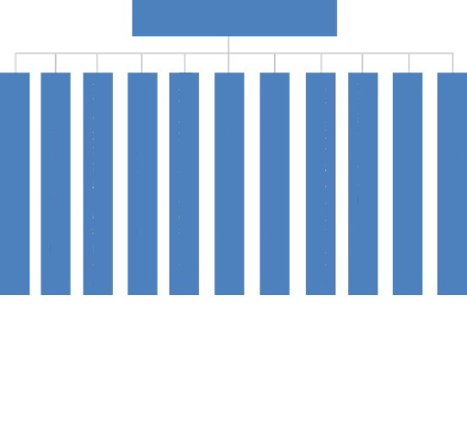

Sieyuan Electric Co., Ltd.

Shanghai Sieyuan Optoelectronics Co., Ltd.

Jiangsu Sieyuan Hertz Instrument Transformer Co., Ltd.

Jiangsu Rugao High Voltage Electrical Appliance Co., Ltd.

Shanghai Sieyuan High Voltage Switchgear Co., Ltd.

Shanghai Sieyuan Power Capacitor Co., Ltd.

Sieyuan Qingneng Electrical & Electronic Co., Ltd.

Shanghai Sieyuan Hongrui Automation Co., Ltd.

Shanghai Sieyuan Power Transmission and Distribution Engineering Co., Ltd.

Jiangsu Juyuan Electric Co., Ltd.

Changzhou Sieyuan Toshiba Transformer Co., Ltd.

Shanghai Timi Automotive Technology Co., Ltd.

## 1.3 Corporate Culture

**Mission: Smarter Power, Better Life**

**Vision: To Become a Global Leader in the Electrical Industry**

**Core Values: Delivering Success to Customers, Innovating and Surmount;** Honesty and Integrity, Openness and Collaboration; Self-criticism and Reflection, Diligence and Perseverance

## 1.4 Company Honors

|  |  |  |
| --- | --- | --- |
| **Major Honors and Awards of Sieyuan Electric in Past Five Years** | | |
| **Year** | **Name** | **Granted by** |
| 2018 | 2018 Shanghai Top 100 Private Enterprises | Shanghai Federation of Enterprises, Shanghai Association of Entrepreneurs, Jiefang Daily |
| 2018 Shanghai Top 100 Private Manufacturing Enterprises | Shanghai Federation of Enterprises, Shanghai Association of Entrepreneurs, Jiefang Daily |
| 2018 Shanghai Top 100 Manufacturing Enterprises | Shanghai Federation of Enterprises, Shanghai Association of Entrepreneurs, Jiefang Daily |
| 2018 Shanghai Top 100 Emerging Industries | Shanghai Federation of Enterprises, Shanghai Association of Entrepreneurs, Jiefang Daily |
| Shanghai Sci-Tech Little Giant Enterprise | Shanghai Municipal Commission of Science and Technology |
| 2016-2017 Shanghai Enterprise of Keeping Promise & Honoring Contract | Shanghai Contract Credit Promotion Association |
| 2016-2017 Level AAA Contract Credit Recognition Certificate | Shanghai Contract Credit Promotion Association |
| 2019 | 2019 Shanghai Top 100 Private Enterprises | Shanghai Federation of Enterprises, Shanghai Association of Entrepreneurs, Jiefang Daily |
| 2019 Shanghai Top 100 Private Manufacturing Enterprises | Shanghai Federation of Enterprises, Shanghai Association of Entrepreneurs, Jiefang Daily |
| 2019 Shanghai Top 100 Manufacturing Enterprises | Shanghai Federation of Enterprises, Shanghai Association of Entrepreneurs, Jiefang Daily |
| 2019 Shanghai Top 100 Emerging Industries | Shanghai Federation of Enterprises, Shanghai Association of Entrepreneurs, Jiefang Daily |
| Shanghai Headquarters of Private Enterprises | Shanghai Municipal Commission of Commerce, Shanghai Municipal Development & Reform Commission, Shanghai Municipal Commission of Economy and Informatization, Shanghai Federation of Industry and Commerce |
| 2020 | 2019 Shanghai Top 100 Private Enterprises | Shanghai Federation of Enterprises, Shanghai Association of Entrepreneurs, Jiefang Daily |
| 2019 Shanghai Top 100 Private Manufacturing Enterprises | Shanghai Federation of Enterprises, Shanghai Association of Entrepreneurs, Jiefang Daily |
| 2019 Shanghai Top 100 Manufacturing Enterprises | Shanghai Federation of Enterprises, Shanghai Association of Entrepreneurs, Jiefang Daily |
| 2019 Shanghai Top 100 Emerging Industries | Shanghai Federation of Enterprises, Shanghai Association of Entrepreneurs, Jiefang Daily |
| 2018-2019 Shanghai Enterprise of Keeping Promise & Honoring Contract | Shanghai Contract Credit Promotion Association |
| 2018-2019 Level AAA Contract Credit Recognition Certificate | Shanghai Contract Credit Promotion Association |
| 2018-2019 Shanghai Demonstration Enterprise of Foreign Trade Self-owned Brand | Shanghai Chamber of Commerce for Import and Export |
| Review of High-Tech Enterprise | Shanghai Municipal Commission of Science and Technology, Shanghai Municipal Finance Bureau, Shanghai Municipal Tax Service, State Taxation Administration, Shanghai Local Taxation Bureau |
| 2021 | 2021 Shanghai Top 100 Private Enterprises | Shanghai Federation of Enterprises, Shanghai Association of Entrepreneurs, Jiefang Daily |
| 2021 Shanghai Top 100 Private Manufacturing Enterprises | Shanghai Federation of Enterprises, Shanghai Association of Entrepreneurs, Jiefang Daily |
| 2021 Shanghai Top 100 Manufacturing Enterprises | Shanghai Federation of Enterprises, Shanghai Association of Entrepreneurs, Jiefang Daily |
| 2021 Shanghai Top 100 Emerging Industries | Shanghai Federation of Enterprises, Shanghai Association of Entrepreneurs, Jiefang Daily |
| Academician (Expert) Workstation in Minhang District | Minhang District Association for Science and Technology |
| 2022 | 2022 Shanghai Top 100 Private Enterprises | Shanghai Federation of Enterprises, Shanghai Association of Entrepreneurs, Jiefang Daily |
| 2022 Shanghai Top 100 Private Manufacturing Enterprises | Shanghai Federation of Enterprises, Shanghai Association of Entrepreneurs, Jiefang Daily |
| 2022 Shanghai Top 100 Manufacturing Enterprises | Shanghai Federation of Enterprises, Shanghai Association of Entrepreneurs, Jiefang Daily |
| 2022 Shanghai Top 100 Emerging Industries | Shanghai Federation of Enterprises, Shanghai Association of Entrepreneurs, Jiefang Daily |
| 2020-2021 Shanghai Enterprise of Keeping Promise & Honoring Contract | Shanghai Contract Credit Promotion Association |
| 2020-2021 Level AAA Contract Credit Recognition Certificate | Shanghai Contract Credit Promotion Association |
| National Enterprise Technology Center | National Development and Reform Commission, Ministry of Science and Technology, Ministry of Finance, General Administration of Customs, State Taxation Administration |
| Innovative Enterprise in Minhang District, Shanghai | Minhang District Economic Commission |
| 2023 | SRDI Enterprise in Minhang District | Minhang District Economic Commission |
| Shanghai SRDI Enterprise | Shanghai Municipal Commission of Economy and Informatization |
| 2020-2022 Shanghai Demonstration Enterprise of Foreign Trade Self-owned Brand | Shanghai Chamber of Commerce for Import and Export |
| Review of High-Tech Enterprise | Shanghai Municipal Commission of Science and Technology, Shanghai Municipal Finance Bureau, Shanghai Municipal Tax Service, State Taxation Administration, Shanghai Local Taxation Bureau |
| 2023 Shanghai Top 50 100-Growing Enterprises (46th Place) | Shanghai Federation of Enterprises, Shanghai Association of Entrepreneurs, Jiefang Daily |
| 2023 Shanghai Top 100 Private Enterprises (47th Place) | Shanghai Federation of Enterprises, Shanghai Association of Entrepreneurs, Jiefang Daily |
| 2023 Shanghai Top 100 Private Manufacturing Enterprises (16th Place) | Shanghai Federation of Enterprises, Shanghai Association of Entrepreneurs, Jiefang Daily |
| 2023 Shanghai Top 100 Enterprises (98th Place) | Shanghai Federation of Enterprises, Shanghai Federation of Economic Organizations, Shanghai Association of Entrepreneurs, Jiefang Daily |
| 2023 Shanghai Top 100 Enterprises in Emerging Industries (29th Place) | Shanghai Federation of Enterprises, Shanghai Association of Entrepreneurs, Jiefang Daily |
| 2023 Shanghai Top 100 Manufacturing Enterprises (31st Place) | Shanghai Federation of Enterprises, Shanghai Federation of Economic Organizations, Shanghai Association of Entrepreneurs, Jiefang Daily |

# 2. Social Responsibility Management

## 2.1. EHS Policies

We are well aware that as an electrical company operating on a global scale, our business activities are not only related to economic benefits, but also closely linked with the safety, health, and environmental regulations of the countries in which it operates. Therefore, we solemnly promise to strictly abide by all relevant laws and regulations, ensuring that every business is legal and compliant.

We consider “sustainable development” as a core element of our strategic plan and strive tirelessly to realize it. We have always been committed to EHS initiatives and have integrated it into our daily operations. We also recognize the importance of continuous improvement, so we continually introduce advanced management concepts and technical means, and strengthen the construction and improvement of EHS management system, contributing to the sustainable development of enterprises and society.

## 2.2 Social Responsibility System

In order to seep the concept of social responsibility into each operation, Sieyuan Electric has established a sound social responsibility system. In this system, the Company sets up a Social Responsibility Management Committee which is chaired by the chairman of the board, with full-time vice presidents as members. The Social Responsibility Management Committee is the decision-making body for CSR issues, responsible for researching and establishing the strategies and policies of corporate social responsibility, participating in the compilation of topics related to social responsibility reports, and dealing with issues related to CSR externally.

It is a crucial mission for Sieyuan Electric to fulfill corporate responsibility. We actively publicize our concepts and practices in social responsibility through a variety of channels, such as new employee onboarding training and platforms such as *Sieyuan People*, in order to help employees gain a deeper understanding and actively participate in them. In the onboarding training of new employees, we play promotional videos and provide cultural concept training to strengthen their awareness of social responsibility. Through these training sessions, employees not only learn about the Company's core values, but also gain insight into our commitment and actions in social responsibility. This approach is not only conducive to strengthening employees' sense of identification with corporate culture, but also driving them to participate in the Company's social responsibility activities.

## 2.3 Communication with Stakeholders

Sieyuan Electric actively identifies stakeholders and fulfills its social responsibilities according to such identification. The Company constantly expands communication channels, conducts extensive and in-depth communication with stakeholders, and actively listens to and understands their voices. In addition, we take targeted measures to respond to their expectations and demand of all stakeholders in time, and grow together with them. In 2023, we identified eight categories of stakeholders: customers, regulatory agencies, suppliers, employees, communities, peers, government, and environment.

The following table lists the main topics which are discussed and fed back by Sieyuan to different stakeholders.

|  |  |  |
| --- | --- | --- |
| **Stakeholders** | **Expectations and Demands** | **Communication and Response** |
| Customers | Provision of High-Quality Products and services  Listening to Customers' Feedback and Suggestions  Protection of Customers’ Information Security | Provision of Product Information  Visit to Customers  Satisfaction Survey |
| Regulatory Agencies | Sustainable Profitability  Standardized Corporate Governance | Improvement of Corporate Governance System  Regular Disclosure of Business Information |
| Suppliers | Adherence to Honest Operation  Promotion of Supplier Development  Fair Trade | Fair and Transparent Procurement Principles and Processes  Deep Cooperation  Honest Trading |
| Employees | Protection of Legitimate Rights and Interests of Employees  Provision of Career Development Opportunities  Care for Physical and Mental Health of Employees  Inclusiveness and Diversity | Establishment of Occupational Health and Safety Management System  Creation of Employee Development Channels  Balance between Employees' Work and Life  Employee Care |
| Communities | Promotion of Community Economic Development  Full Communication and Harmonious Co-existing with Communities  Multi-level and multi-dimensional Cooperation  Community Public Welfare | Support for Employment  Engagement in Community Building  Public Welfare Programs  Voluntary Service Activities in Community |
| Peers | Technical Exchange  Collaborative Innovation  Industry Development | Industry Conference  Seminar  Industry-Academia-Research Collaboration |
| Government | Tax Payment in Full by Law  Leading in Technological Innovation  Promotion of Social Employment | Active Tax Payment  Technical Innovation  Provision of Job Opportunities |
| Environment | Environmental Protection  Energy Conservation & Emission Reduction  Low-Carbon Development | Green Manufacturing  Improvement of Energy Management System  Green Office  Product Carbon Footprint Verification |

## 2.4 Analysis of Material Topics

To effectively respond to the demands of all sectors of society on Sieyuan Electric and better fulfill its social responsibilities, Sieyuan identifies and evaluates material topics by means of external benchmarking, internal interviews and industry trend analysis, in the light of its own business conditions and strategic targets. In addition, based on the two dimensions of "the materiality to stakeholder evaluation and decision-making" and "the materiality to the Company's economic, environmental and social impact", we construct a matrix of material topics to steer the direction of sustainable development, provide an important basis for our sustainable development, ensure actively fulfilling social responsibilities while pursuing economic benefits, and achieve sustainable development targets.



Business Ethics

Compliant Business Operation

Internal Control System

Information Security

Employees’ Rights and Benefits

Occupational Health and Safety

Product Quality

Employee Care

Innovation and R&D

Equality and Diversity

Industry Cooperation

Sustainable Procurement

Public Welfare

Pollution Prevention and Control

Energy Conservation and Consumption Reduction

Green Operation

Employee Development

Low

Medium

High

Low

Medium

High

Materiality to the Company's economic, environmental and social impact

Materiality to assessment and decision-making of stakeholders

Environment

Governance

Society

# 3. Long-term Planning to Maintain Prudent Operation

Sieyuan Electric knows that good corporate governance is the cornerstone of healthy and efficient operation. We observe business ethics, adhere to compliant operations, and improve the internal control system, in order to enhance governance efficiency and boost the sustainable development of the Company.

## 3.1 Governance Structure

Sieyuan Electric strictly adheres to laws and regulations such as the *Company Law of the People's Republic of China*, the *Securities Law of the People's Republic of China*, as well as relevant regulations of the China Securities Regulatory Commission. We establish a governance framework composed of the shareholders’ meeting, the board of directors, the board of supervisors and the management. The shareholders’ meeting, the board of directors and the board of supervisors operate independently. We have established a governance mechanism of "statutorily defined powers and responsibilities, transparent rights and responsibilities, coordinated operation, and effective checks and balances", laying a solid foundation for the high-quality development of the Company.

* **Stockholders' Meeting**

The shareholders' meeting is the highest authority of the Company, which makes decisions on major issues and safeguarding the legitimate rights and interests of all shareholders. In strict accordance with laws and regulations, normative documents, the *Articles of Association* and the *Rules of Procedure for the Shareholders' Meeting*, Sieyuan Electric standardizes the procedures for convening, holding, proposing, and voting at shareholders' meetings.

* **Board of Directors**

The board of directors is the decision-making body of the Company, accountable to the shareholders' meeting and reporting its work to the shareholders' meeting. The directors of the Company perform their duties and implement the resolutions of the shareholders' meeting in strict accordance with the *Company Law*, the *Articles of Association*, the *Rules of Procedure of the Board of Directors* and other relevant provisions. The Company currently has 7 directors, including 1 chairman and 1 vice-chairman, and 3 independent directors, accounting for more than one-third of all directors, 2 of whom are accounting professionals, meeting the requirements of the *Rules for Independent Directors of Listed Companies* of the China Securities Regulatory Commission.

The board of directors has set up an audit committee, a compensation and assessment committee, and an investment decision-making committee, which strictly fulfill their duties in accordance with relevant regulations and operates well.

* **Board of Supervisors**

The board of supervisors is the supervisory body of the Company, responsible for reviewing and giving written audit opinions on the Company's securities issuance documents and periodic reports prepared by the board of directors, supervising the directors and senior executives in performing their duties, and inspecting the Company's financial affairs. The Company currently has 3 supervisors, including 1 employee representative supervisor, the number and composition of which comply with relevant laws and regulations.

## 3.2 Internal Control System

Sieyuan Electric has been committed to improving the internal control system to ensure the operations are effective and sustainable. Therefore, the Company sets up an audit and internal control department as the daily supervision body of internal control, and formulated strict internal audit system and management system to normalize the audit and supervision. In order to achieve proper internal control of each subsidiary, the audit and internal control department conducts a routine comprehensive audit on important subsidiaries once a year. Internal control teams are also set up in each subsidiary. Audit committee, audit and internal control department, and internal control teams form a three-level internal control organization. At the beginning of each year, the audit and internal control department issues an annual plan of internal control self-examination, and the internal control team of each subsidiary carries out routine and special audits on a monthly basis as needed. On the basis of internal control evaluation, the audit committee and the audit and internal control department review the establishment, optimization and implementation of the Company's internal control systems, put forward rectification opinions in time, and supervise the completion of rectification.

During the reporting period, the Company continued to make efforts in internal control according to the *Basic Norms for Enterprise Internal Control*, the *Supporting Guidelines for Enterprise Internal Control*, the *Standard Manual for Internal Control of Sieyuan Electric*, and national laws, norms, rules and regulations, etc., to further standardize the Company's operations and effectively improve the Company's overall internal control.

## 3.3 Compliant Business Operation

Sieyuan Electric adheres to a compliance-oriented approach and continuously improves the Company's compliance system. The Company has established a compliance organization with the chairman as the top person in charge, and set up a compliance management committee to supervise the overall implementation of the compliance management policies of Sieyuan Group. Moreover, the Company holds compliance meetings every quarter to check whether the compliance actions are effective.

At the beginning of each year, the compliance management department prepares a compliance review plan, selects key compliance risk areas in the plan, and conducts compliance review and due diligence on bidding products, risky projects, and business partners. The Company incorporates compliance training into the training program for all employees, especially for senior executives, compliance teams, high-risk areas, and key positions. It publishes work information and developments in the form of briefings and notifications, promote advanced experience, publicize compliance awareness, and promote the communication of compliance concepts and the improvement of compliance management level of the Group and its subsidiaries.

## 3.4 Business Ethics

Sieyuan Electric is committed to creating a clean, honest, fair and just business environment, and resolutely opposes corruption, unfair competition and other forms of violations of business ethics. The Company has formulated and implemented the *Code of Conduct and Code of Business Ethics of Sieyuan Electric*, regulating the business conduct and ethics of all employees.

To boost the business ethics training for employees, Sieyuan Electric develops a comprehensive training plan, and regularly conducts business ethics education activities. The training covers the basic principles of business ethics, code of conduct, and professional integrity, aiming to help employees fully understand the importance and connotation of business ethics, constantly enhance their business ethics awareness, and guide them to set correct business ethics.

**Business Ethics Statistics**

|  |  |  |  |  |
| --- | --- | --- | --- | --- |
| **Indicator** | **Unit** | **2023** | **2022** | **2021** |
| Total number of business ethics training sessions | Time | 8 | - | - |
| Number of employees receiving business ethics training | Person | 7832 | 6684 | 6099 |
| Average hours of business ethics training per employee | Hour | 1 | 1 | 1 |
| Coverage rate of business ethics training (all employees) | % | 100 | 100 | 100 |

The Company has opened a channel for reporting violations of business ethics. Any employees, suppliers and other stakeholders can report such violations to the Company. The company will keep the information of the whistleblowers strictly confidential. For acts violating business ethics, the Company will seriously investigate and correct them according to relevant systems. Those suspected of violating laws and crimes will be transferred to judicial organs.

During the reporting period, the Company did not receive any complaint or report on violation of business ethics.

|  |  |  |  |  |
| --- | --- | --- | --- | --- |
| **Indicator** | **Unit** | **2023** | **2022** | **2021** |
| Total number of complains and whistle-blowing received | Time | 0 | 0 | 0 |
| - Whistleblowing from employees | Time | 0 | 0 | 0 |
| - Whistleblowing from suppliers/contractors | Time | 0 | 0 | 0 |
| - Whistleblowing from other stakeholders | Time | 0 | 0 | 0 |

* **Anti-Corruption and Anti-Bribery**

We have always adhered to the principle of anti-corruption and integrity, resolutely resisted corrupt practices, strengthened the supervision of corruption and bribery, and promptly discovered and dealt with violations. The Company requires employees in management and other sensitive positions (such as those involved in procurement) to sign the *Letter of Commitment on Integrity in Duty Performance*, strictly abide by the commitment, and resolutely prevent against illegal and irregular behaviors such as corruption and bribery.

During the reporting period, 100% of employees at all levels were trained on anti-corruption and anti-bribery in Sieyuan Electric. No confirmed cases of corruption were found throughout the year.

* **Fair Competition**

The Company strictly follows relevant laws and regulations such as the *Anti-Unfair Competition Law of the People’s Republic of China* and *the Anti-Monopoly Law of the People’s Republic of China*, and resolutely opposes all forms of unfair competition. Sieyuan Electric respects every competitor, regards excellent competitors as the driving force for innovation and change, and advocates gaining competitive advantages with excellent quality and service. We promise not to engage in price fixing or malicious competition, and never engage in any false advertising, misleading conduct or fraudulent activities.

Moreover, the Company intensifies fair competition training for employees, and strictly prohibits employees from obtaining competitors' trade secrets and confidential information through wrongful methods, so as to maintain an honest and fair competition mechanism and actively create a healthy and transparent business atmosphere and a favorable business competition environment. During the reporting period, the Company did not engage in any legal proceedings related to unfair competition.

## 3.5 Information Security and Privacy Protection

In Sieyuan Electric, the information security is managed with the policy of "prevention first, comprehensive precaution, systematic management, meeting customer needs, providing stable, reliable and safe high-quality services, and maintaining continuous improvement".

In order to ensure the confidentiality, integrity and availability of information assets and provide customers with more reliable services, Sieyuan Electric establishes an information security management system according to ISO/IEC 27001:2013 to fully protect the information security of customers and the Company. The system can identify all information assets involved in the Company's business operations and customer services, scientifically and efficiently classify them, and determine the associated risks. Subsequently, we take appropriate measures to reduce these risks to meet the requirements of laws and regulations. We continuously make improvements to ensure the security of information assets, enhance customer confidence, and maintain business continuity.

The Information Technology Department of the Company centrally manages the information system construction. It establishes sound regimes and mechanisms for information system management, enabling effective management of IT operation and maintenance, general system security, system log review, system development and change, data backup, etc. Moreover, the Department regularly inspects each system to ensure the information system runs normally and enhance its security and reliability.

Furthermore, the Company strictly protects privacy. The Company agrees in the contract signed with employees that 1) it is prohibited to use the business, accounts, finance, research and development, projects, trade secrets, operating strategies, bidding information or any other potentially sensitive or confidential information involving Sieyuan, Sieyuan's customers or business partners for personal purposes, or to disclose such information to any person or organization; 2) it is prohibited to disclose information about the business, customers or business partners learned in business to anyone other than Sieyuan; 3) it is not allowed to share or disclose information about Sieyuan, the business or any third party related to the business through social media.

During the reporting period, no information security incidents or privacy infringements occurred in Sieyuan Electric and its subsidiaries.

## 3.6 Information Disclosure

Sieyuan Electric strictly abides by the relevant provisions of the *Company Law of the People's Republic of China*, the *Securities Law of the People's Republic of China*, the *Administrative Measures on Information Disclosure by Listed Companies*, the *Accountability System for Major Errors in Information Disclosure of the Company's Annual Report*, the *System for Reporting by the Company's Knowledgeable Persons of Insider Information*, and other laws and regulations. It has established the *Information Disclosure Management System* and strictly fulfills its information disclosure obligations.

We actively coordinates investor relations to ensure that the information disclosure is true, accurate, complete, promptly and open. The documents with information disclosure mainly include regular reports, interim reports, and other content that should be disclosed, which are disclosed through the *Securities Times* and http://www.cninfo.com.cn.

In addition, the Company has established a management system related to internal information transfer, standardized business operations such as production and operation information transfer, official document transfer, financial information transfer, conference information transfer, and internal information insider management, so as to ensure that the internal reporting system is compliant, complete, sound, and scientific, keep the internal reporting process rigorous, strengthen the integration and sharing of internal reporting information, and ensure internal information transfer in a timely manner via smooth channels.

# 4. Win-Win Cooperation to Grow Together

Sieyuan Electric always holds to the corporate vision of providing first-class electrical equipment and services to global customers, and helping them use and maintain electricity safely, reliably and efficiently. It vigorously implements an innovation-driven development strategy to improve product quality, provide customers with high-quality and thoughtful services, and continuously enhancing customer satisfaction. We take it as our responsibility to create a sustainable supply chain, work together with all parties to promote industry development, and maintain a good industry ecology.

## 4.1 Innovation-driven Development

As a well-known domestic listed company specializing in power technology research and development, equipment manufacturing, and engineering services, Sieyuan Electric attaches great importance to the supporting role of innovation. The Company has increased investment in research and development, overcome one technical difficulty after another, and mastered a number of advanced or leading core technologies at home and abroad. The Company develops the technologies based on products and Academia Sinica, forming a platform-based economy of scale. Besides, the Company also increases investment in forward-looking technologies, such as flexible DC power transmission, optoelectronic technology, new energy, energy storage, Internet of things, and automotive electronics. We actively seize the innovation heights to lay the foundation for the expansion of future new businesses.

Sieyuan Electrics steadily promotes the construction of its integrated product development system, providing technical and organizational support for the rapid launch of technologically leading, high-quality and low-cost products.

In 2023, the Company took great pains to talent training and industry-academia-research collaboration with well-known universities such as Tsinghua University, Shanghai Jiao Tong University, Xi'an Jiaotong University, Huazhong University of Science and Technology, North China Electric Power University, Hunan University and Southwest Jiaotong University, realizing resource sharing and mutual complementarity in advantages, and promoting the transformation and application of the Company's scientific research achievements.

In 2023, Sieyuan Electric was granted the High-Tech Enterprise Certificate by Shanghai Municipal Commission of Science and Technology, Shanghai Municipal Finance Bureau and Shanghai Municipal Tax Service, State Taxation Administration.

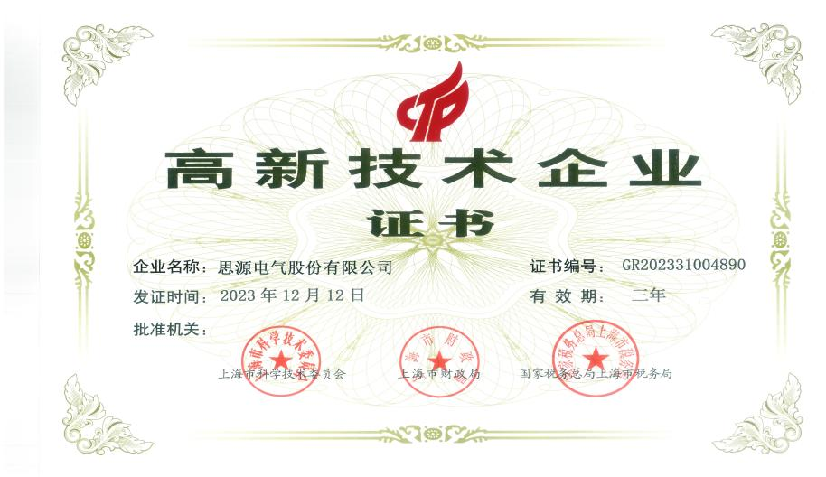

|  |
| --- |
| **Case Study: Sieyuan Hongrui hybrid supercapacitor power system was conducive to improving the quality and efficiency of power distribution network.**  The SC-551 hybrid supercapacitor power supply system developed by Shanghai Sieyuan Hongrui Automation Co., Ltd., a subsidiary of Sieyuan Electric, has been officially launched. This product can be typically applied in the field of distribution terminals, effectively supporting the performance requirements of power distribution terminals for backup batteries.  C:/Users/DOU/Desktop/微信图片_20240413094450.png微信图片_20240413094450  The power supply system combines lithium battery with supercapacitor, and adopts the method of "connecting multiple hybrid supercapacitors in series into a module" in the innovative technical design. It can apply to online and handheld terminal operation and maintenance solutions, and has excellent performance at low temperature. It inherits the advantages of high energy density of lithium batteries and the high power density and long service life of supercapacitors. It resolves the problems of narrow operating temperature range, short service life and corrosion by leakage solution of the traditional backup power supply (mostly lead-acid batteries) in the power system, overcomes the shortcomings of poor low-temperature performance of lithium batteries and low energy density of supercapacitors, and enables remote sensing, diagnosis and early warning of power supplies. |

## 4.2 Product Quality

### 4.2.1 Quality Management System

Sieyuan Electric strictly adheres to domestic and international policies and standards concerning product quality and safety such as the *Law of the People's Republic of China on Product Quality* and the *Standardization Law of the People’s Republic of China*. It formulates and implements quality plans, and defines quality objectives and strategies. The Company actively implements the ISO 9001 quality management system and strictly controls all quality links to guarantee high product quality. The subsidiaries have also established quality assurance system, and actively used comprehensive quality management tools, lean improvement, quality control circle (QCC), employee proposal improvement, project management and other quality improvement tools to continuously improve product quality and project delivery quality. During the reporting period, Sieyuan Electric was certified for the ISO9001:2015 quality management system.

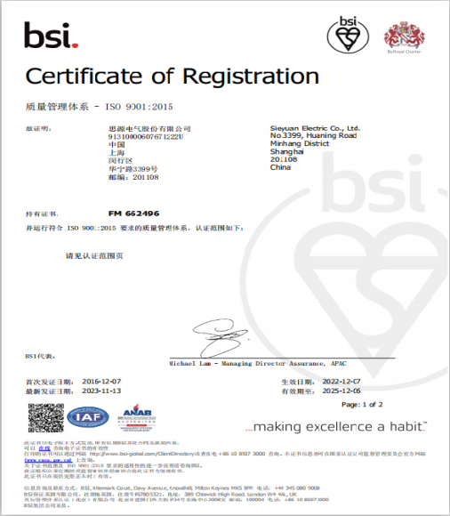

**Quality Management System Certification of Sieyuan Electric and Its Subsidiaries**

|  |  |  |  |  |  |  |
| --- | --- | --- | --- | --- | --- | --- |
| **S/N** | **Enterprise Names** | **Business Type** | **Certification Awarded** | **Certificate No.** | **Effective Date** | **Validity Period** |
| 1 | Sieyuan Electric Co., Ltd. | Manufacturing | Yes | FM 662496 | 2022/12/7 | 2025/12/6 |
| 2 | Shanghai Sieyuan High Voltage Switchgear Co., Ltd. | Manufacturing | Yes | FM 662501 | 2022/12/7 | 2025/12/6 |
| 3 | Jiangsu Rugao High Voltage Electrical Appliance Co., Ltd. | Manufacturing | Yes | FM 660809 | 2022/10/10 | 2025/10/9 |
| 4 | Shanghai Sieyuan Optoelectronics Co., Ltd. | Manufacturing | Yes | FM 731412 | 2023/8/22 | 2026/9/14 |
| 5 | Jiangsu Sieyuan Hertz Instrument Transformer Co., Ltd. | Manufacturing | Yes | FM 661556 | 2022/11/7 | 2025/11/6 |
| 6 | Shanghai Sieyuan Power Capacitor Co., Ltd. | Manufacturing | Yes | FM 660779 | 2022/11/1 | 2025/10/31 |
| 7 | Shanghai Sieyuan Hongrui Automation Co., Ltd. | Production | Yes | FM 661845 | 2022/11/2 | 2025/11/1 |
| 8 | Sieyuan Qingneng Electrical & Electronic Co., Ltd. | Production | Yes | FM 658933 | 2022/8/23 | 2025/8/22 |
| 9 | Changzhou Sieyuan Toshiba Transformer Co., Ltd. | Manufacturing | Yes | U006623Q0265R2M | 2023/7/31 | 2026/8/6 |
| 10 | Jiangsu Sieyuan Medium Voltage Switchgear Co., Ltd. | Manufacturing | Yes | 21179Q10185ROM | 2021/8/20 | 2024/8/19 |
| 11 | Shanghai Sieyuan Power Transmission and Distribution Engineering Co., Ltd. | Manufacturing | Yes | 0422Q10459R0M-EC | 2022/12/1 | 2025/11/30 |
| 12 | Jiangsu Juyuan Electric Co., Ltd. | Manufacturing | Yes | 00123Q39936R2M/3200 | 2023/12/4 | 2026/12/5 |
| 13 | GMCC Electronic Technology Wuxi Co., Ltd. | Production | Yes | 1210051240 | 2024/3/1 | 2027/2/28 |

* **Quality Policy**

In order to achieve the goal of high customer satisfaction, ensure that customer requirements and expectations are identified and translated into the Company's requirements for products and services, Sieyuan Electric adheres to the quality policy that “we take quality leadership as our long-term competitive strategy for development, strive for high quality in every activity through full participation, whole process planning, control and continuous improvement, and meet customer needs with excellent products and services”.

* **Quality Organizational Structure**

The Company has a complete quality organizational structure to ensure the effective operation of the quality system. A process quality and technology management department is set at the headquarters. A process and quality management department is established for each production line.

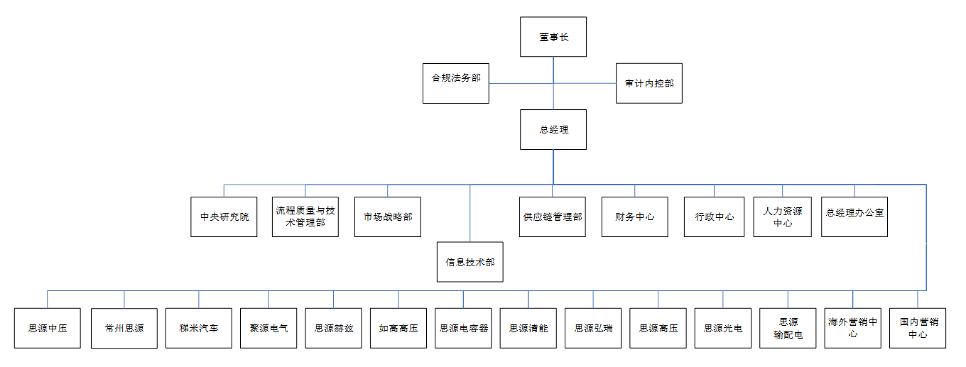

Sieyuan Optoelectronics

Domestic Marketing Center

Sieyuan Power Transmission & Distribution

Overseas Marketing Center

Ruigao High Voltage

Sieyuan High Voltage

Sieyuan Hongrui

Sieyuan Qingneng

Sieyuan Capacitor

Sieyuan Hertz

Juyuan Electric

Timi Automotive

Changzhou Sieyuan

Sieyuan Medium Voltage

Information Technology Dept.

General Manager Office

Human Resources Center

Administration Center

Finance Center

Supply Chain Management Department

Marketing Strategy Dept.

Process Quality and Technology Management Dept.

Academia Sinica

Chairman

General Manager

Compliance and Legal Affairs Dept.

Audit and Internal Control Dept.

* **Quality Culture Construction**

Sieyuan Electric persistently carries out a variety of quality activities and continues to promote the development of quality culture. In April 2023, the Company's process quality and technology management department held an "Award-winning Competition on Quality Knowledge in Joint Stock Company". A representative team consisting of 9 production lines, Academia Sinica, and Global Engineering Service Center participated in the competition. This competition deepened the staff's understanding of quality knowledge, and creating a united, tense, serious and lively quality atmosphere where everyone values and participates in quality control.

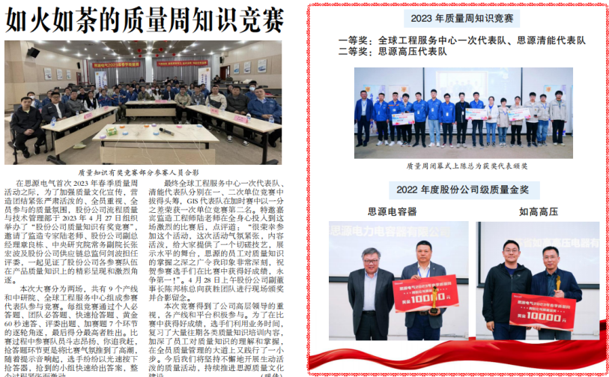

Moreover, the Company conducts process audits every year, focusing on 8D corrective and preventive norms, rewards and punishments, etc., and promoting the rectification of 219 problems, of which the closure rate of serious and general problems was 100%.

### 4.2.2 Management of Nonconforming Products

In order to more effectively manage the review and rectification of non-conforming parts, process abnormalities, and customer abnormalities, the Company has established a quality exception database, and conducts monthly statistics and evaluations on the effect of rectification measures implemented, so as to monitor and promote the improvement for all kinds of abnormalities. In addition, in order to strengthen quality management, the Company regularly holds weekly and monthly quality meetings to review various problems, systematically improve product quality, and constantly meet and exceed customer expectations.

In view of product quality or safety problems, the Company has established recall management methods, and improved the processes of product return and recall, in order to recall the products by the fastest and most effective means in case of safety risks or quality problems, and strictly protect the personal health and life safety of customers. The recall management measures stipulate the return of products and their handling methods, and define the roles and responsibilities, ensuring that the products can be recalled in an orderly and efficient manner.

In 2023, there were no product recalls in the Company.

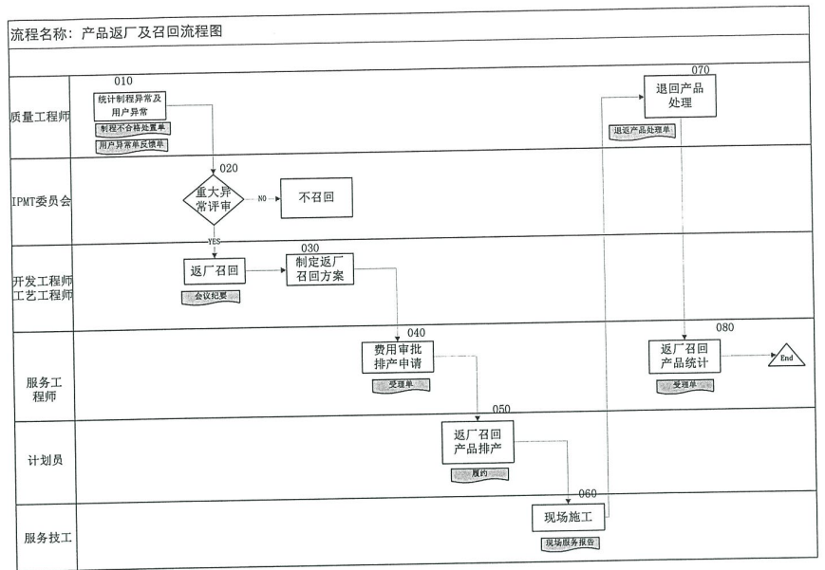

Process Name: Flow Chart of Product Return and Recall

Quality Engineer

IPMT Committee

Development Engineer

Process Engineer

Service Engineer

Planner

Service Technician

Statistics on process and user abnormalities

Handling sheet of process failure

Feedback on user abnormalities

Review on major abnormalities

No recall

Recall

Minutes of meeting

Receipt

Contract performance

On-site service report

Receipt

Returned product treatment

Development of recall plan

Expense approval and scheduling request

Return, recall and production scheduling

On-site construction

Handling sheet of returned product

Statistics on products returned and recalled

## 4.3 Customer Services

Sieyuan Electric strictly abides by the *Law of the People's Republic of China on Protection of Consumer Rights and Interests*, adheres to the concept of "satisfying customers", centers on customers’ demand, continuously provides value-added services, and creates long-term value for customers. The Company attaches great importance to long-term strategic cooperation with key customers, advocates the concept of "growing together with customers", actively participates in and cooperates with key customers in project research and development, product design or IoT construction, and strives to become an important part of its supply chain. In addition, the Company strives to develop long-term key customers and diversifies customer resources appropriately.

Sieyuan Electric has established a cross-product sales and customer service platform for domestic and overseas markets respectively, providing customers with one-stop comprehensive services, fully meeting their needs, enhancing customer stickiness, and further increasing market share.

The Company has formulated customer complaint management methods and established a customer complaint platform to strengthen communication with customers. It can immediately review and handle customer complaints, quickly respond to customer needs, effectively solve customer problems, and enhance customer trust in the Company. The Company sets up a special complaint handling department and a special person responsible to receive and handle complaints, ensuring the complaint information is collected and recorded in time.

We pay special attention to every customer's feedback and complaint, establish a standardized operation specification for customer complaints, ensuring that every customer complaint can be handled in a timely and professional manner. We also track and supervise the whole process to ensure that problems are thoroughly resolved.

Regarding customer satisfaction as an important work indicator, we have established an effective communication mechanism with customers, so as to better identify the problems existing in the current services, actively improve them, and fully understand the customer satisfaction with our products and services. During the reporting period, the cumulative satisfaction value was 98.07% for the Company's domestic contract delivery, and 99.40% for overseas contract delivery, which fully indicates that the services of Sieyuan Electric were highly recognized and evaluated by customers.

## 4.4 Sustainable Supply Chain

The Company places great emphasis on supply chain management, and always adheres to the principle of "fairness, justice and openness", striving to convey the concept of sustainable development to upstream and downstream enterprises in the supply chain, and building a sustainable supply chain with mutual trust, mutual benefit and win-win cooperation.

### 4.4.1 Supplier Management

When selecting its suppliers, Sieyuan Electric follows the "open door" policy to create an open and free competitive market for them and ensure fairness and impartiality in the selection process. The Company not only verifies and confirms the qualifications, supply capacity, quality and other indicators of suppliers, but also evaluates and considers their ESG management and practical capabilities. When establishing a contractual relationship with suppliers, the Company transmits its social responsibility management system and policy to the suppliers, require them to sign the Letter of Undertaking on Social Responsibilities, and incorporate social responsibility clauses in the procurement contract.

The Company regularly audits the suppliers on site, promptly informs them of problems and defects found during audit, in order to urge them to rectify. We prepare a supplier social responsibility file to keep evidence and records of supplier audit results and improvement measures. We also actively carry out due diligence, urging and helping them to actively fulfill their ESG responsibilities.

**Performance in Supplier Management of Sieyuan Electric in 2023**

|  |  |  |
| --- | --- | --- |
| Indicator | Unit | 2023 |
| Total number of suppliers | Nos. | 2859 |
| Suppliers who completed social responsibility questionnaire | Nos. | 160 |
| Suppliers who undergone on-site social responsibility audit | Nos. | 160 |
| Suppliers who signed the *Supplier Code of Conduct* | Nos. | 218 |
| Suppliers who signed the *Social Responsibility Framework Agreement* | Nos. | 156 |
| Number of key or core suppliers | Nos. | 88 |
| Key suppliers who completed social responsibility questionnaire | Nos. | 88 |
| Key suppliers who undergone on-site social responsibility audit | Nos. | 88 |
| Key suppliers who signed the *Supplier Code of Conduct* | Nos. | 88 |
| Key suppliers who signed the *Social Responsibility Framework Agreement* | Nos. | 88 |
| New suppliers in current year | Nos. | 218 |
| New suppliers who completed social responsibility questionnaire | Nos. | 180 |
| New suppliers who undergone on-site social responsibility audit | Nos. | 180 |
| New suppliers who signed the *Supplier Code of Conduct* | Nos. | 218 |
| New suppliers who signed the *Social Responsibility Framework Agreement* | Nos. | 218 |
| Potential suppliers who completed social responsibility assessment | Nos. | 56 |
| Percentage of potential suppliers who completed social responsibility assessment | % | 56 |
| Percentage of suppliers who received social responsibility training | % | 100 |

In addition, we fully listens to the opinions of suppliers, set up a variety of supplier relationship management systems and measures such as follow-up by audit department, complaint mailbox, exchange with management staff, and supplier conference, in order to protect the legitimate rights and interests of suppliers and enhance the good business relationship with them.

### 4.4.2 Purchaser Management

We are committed to improving the awareness of integrity and sustainability of our purchasers to ensure that the procurement process is legal and compliant. We provide sustainable procurement training for purchasers, including but not limited to knowledge on the social and environmental impacts of the supply chain, human rights protection, and labor rights. Moreover, we include the sustainable development capability of the supply chain into the performance evaluation system of purchasers. During the reporting period, 100% of purchasers were trained on sustainable procurement in the Company.

**List of Purchaser Data for Sieyuan Electric**

|  |  |  |  |  |
| --- | --- | --- | --- | --- |
| Indicator | Unit | 2023 | 2022 | 2021 |
| Number of purchasers | Person | 98 | 82 | 79 |
| Number of purchasers trained on sustainable procurement | Person | 98 | 82 | 79 |
| Percentage of purchasers trained on sustainable procurement in all regions | % | 100 | 100 | 100 |

## 4.5 Industry Cooperation

### 4.5.1 Industry Exchange

Sieyuan Electric actively participates in relevant industry associations, including the China High Voltage Apparatus Network, the Standardization Technical Committee for High Voltage Switchgear and DC Power Supply in the Power Industry, the National Standardization Technical Committee for High Voltage Switchgear, and the High Voltage Switchgear Branch of the China Electrical Equipment Industry Association. It also participates in industry exhibitions, promotes industry concepts and advanced models, and creates sound development ecology for the industry.

|  |
| --- |
| Case Study: Sieyuan Electric exhibited multiple energy storage products at the 2nd International Energy Storage Conference. From August 30 to September 1, 2023, the 2nd International Energy Storage Conference and the 10th Global Solar + Energy Storage Conference & Expo were grandly opened at Suzhou International Expo Center. Sieyuan Electric brought esGrid station-level energy storage system (air-cooled/liquid-cooled), supercapacitor energy storage system, SGS\_Plus enhanced power grid stabilizer and a full range of household energy storage products to the exhibition site.  IMG_256  IMG_256  This Conference enhanced the communication and exchange between Sieyuan and upstream and downstream partners in the industrial chain, and strengthened mutual trust, with great significance for a new chapter of win-win cooperation. |

### 4.5.2 Standard Development

Sieyuan Electric gives full play to its technical strength and industry experience, proposes forward-looking and practical recommendations, actively participates in the development and revision of national and industry standards, and leads the industrial development in a normalized, standardized and healthy way.

**Information on Standards Drafted by Sieyuan Electric**

|  |  |  |  |  |  |
| --- | --- | --- | --- | --- | --- |
| **S/N** | **Standard No.** | **Standard Level** | **Standard Name** | **Release Date** | **Status** |
| 1 | GB/T 42287-2022 | National | High-Voltage Test Techniques - Measurement of Partial Discharges by Electromagnetic and Acoustic Methods | 2022-12-30 | In force |
| 2 | GB/T 2900.19-2022 | National | Electrotechnical Terminology - High-Voltage Test Technique and Insulation Co-ordination | 2022-10-12 | In force |
| 3 | T/CSEE 0280—2021 | Group | Design Code for Complete Set of Medium Voltage Flexible DC Distribution Network | 2021-09-17 | In force |
| 4 | T/CSEE 0279—2021 | Group | Guide for System Commissioning of Medium Voltage Flexible DC Distribution Network | 2021-09-17 | In force |
| 5 | T/CSEE 0259—2021 | Group | Thyristor Controlled Reactors (TCT) Controllable Reactor Devices - Application Guidelines | 2021-09-17 | In force |
| 6 | T/CSEE 0241.18—2021 | Group | Flexible DC Grid - Part 18: Technical Specifications for High Voltage DC Circuit Breakers | 2021-03-11 | In force |
| 7 | T/CEC 256—2019 | Group | Technical Specifications for Hybrid HVDC Circuit Breakers | 2019-11-21 | In force |
| 8 | T/CSEE 0055—2017 | Group | Inspection Rules for Line Selection Device for Single-Phase Grounding Fault in Small Current Grounding System | 2018-02-28 | In force |
| 9 | GB/T 34870.1-2017 | National | Super Capacitors - Part 1: General | 2017-11-01 | In force |
| 10 | GB/T 34121-2017 | National | Technical Specification for Relay Protection Configuration Tool in Smart Substation | 2017-07-31 | In force |

# 5. Employee Empowerment to Inspire Their Potential

Sieyuan Electric treats employees as the valuable assets, and regards the cultivation of professional talents and the enhancement of organizational vitality as an important goal in corporate development strategy. We always advocate and follow the value concept of "putting people first", constantly improve the human resource management system, improve the compensation and incentive mechanism, and provide a platform for employees to realize self-actualization.

We respect and protect the basic rights and interests of employees, provide good benefits and development opportunities to them, pay full attention to their growth, safeguard their safety and health, build a career platform to show their capabilities and creativity, and create a better life with each employee.

## 5.1 Compliant Employment

Sieyuan Electric strictly abides by the *Labor Law of the People's Republic of China*, the *Labor Contract Law of the People's Republic of China* and other laws and regulations, actively promotes the integration of business and human resources, optimizes the organizational structure, activates the organization and employees, continuously improves the organizational capabilities and human resource efficiency, further strengthens the international business capacity, and improves the overall consistency of the Company. Specifically, we effectively implement the strategies through strategic performance management; further strengthen job qualifications, job recruitment, and dynamic post management to enable excellent talents to stand out; strengthen the management over cross-functional team performance and enhance the performance abilities of employees; gradually establish training system based on the Company's strategy and qualification requirements to drive staff growth; assess the core values of employees and the "Four Dares and One Courage" of cadres, increase the employee engagement, and strengthen the abilities of the cadres, so as to enhance their cohesiveness and competence.

With the continuous business expansion, the Company adheres to the principle of “equality, fairness and impartiality” in hiring employees, widely absorbing employees from different fields and backgrounds, effectively promoting the construction of a compliant, equal and inclusive employment system, and prohibiting the use of any coercive or deceptive means to attract applicants. We do not discriminate against job applicants due to their nationality, race, color, ethnicity, religion, age, disability, gender, marital status, sexual orientation, etc.

As of the end of 2023, Sieyuan Electric had 7,832 employees, including 5,955 male employees, accounting for 76.03%, and 1,877 female employees, accounting for 24.00%. There were 168 senior managers, of which 55 were women, accounting for <32.70%.

**Staffing Overview**

|  |  |  |  |  |
| --- | --- | --- | --- | --- |
| Indicator | Unit | 2023 | 2022 | 2021 |
| Number of new employees | Person | 2,424 | 1,808 | 1,781 |
| Total number of employees | Person | 7,832 | 6,684 | 6,099 |
| Number of employees with disabilities | Person | 21 | 19 | 20 |
| Percentage of employees with disabilities | % | 0.27 | 0.28 | 0.33 |
| Percentage of employees undergoing performance and career development assessments | % | 100 | 100 | 100 |
| **Gender Structure** | | | | |
| Total number of female employees | Person | 1,877 | 1,616 | 1,516 |
| Percentage of female employees in the total workforce | % | 24.00 | 24.20 | 24.90 |
| Number of executives (excluding Board of Directors) | Person | 168 | 151 | 143 |
| Number of female executives | Person | 55 | 51 | 46 |
| Percentage of female executives | % | 32.70 | 33.80 | 32.20 |
| Number of Board of Directors | Person | 7 | 7 | 7 |
| **Age Structure** | | | | |
| Number of employees under 30 years old | Person | 2,391 | 1,837 | 1,675 |
| Number of employees between 0 and 50 years old | Person | 5,098 | 4,541 | 4,147 |
| Number of employees over 50 years old | Person | 343 | 306 | 277 |
| Percentage of employees under 30 years old | % | 30.50 | 27.50 | 27.50 |
| Percentage of employees between 30 and 50 years old | % | 65.10 | 67.90 | 68.00 |
| Percentage of employees over 50 years old | % | 4.40 | 4.60 | 4.50 |
| **Educational Background Structure (proportion of employees in the following categories in the total number of employees)** | | | | |
| Number of employees with doctoral and post-doctoral degree | Person | 16 | 9 | 10 |
| Percentage of employees with doctoral and post-doctoral degree | % | 0.20 | 0.10 | 0.20 |
| Number of employees with master's degree | Person | 595 | 447 | 393 |
| Percentage of employees with doctoral and post-doctoral degree | % | 7.60 | 6.70 | 6.40 |
| Number of employees with bachelor's degree | Person | 2,937 | 2,432 | 2,145 |
| Percentage of employees with doctoral and post-doctoral degree | % | 37.50 | 36.40 | 35.20 |
| Number of employees with associate degree | Person | 1,597 | 1,334 | 1,262 |
| Percentage of employees with doctoral and post-doctoral degree | % | 20.40 | 20.00 | 20.70 |

## 5.2 Employees’ Rights and Benefits

Sieyuan Electric strictly complies with the *International Labor Organization’s Declaration on Fundamental Principles and Rights at Work*, the *Labor Law of the People's Republic of China*, the *Labor Contract Law of the People's Republic of China*, and other local laws and regulations. We practice the principle of compliant employment, respect and protect employees, and resolutely oppose any form of discrimination, harassment or retaliation in the workplace. During the reporting period, the Company regularly organized training for employees on labor rights protection, and all employees received training on human rights. In 2023, the Company did not have any violations of legal system concerning employee's human rights, such as employment discrimination, harassment, child labor, and forced labor.

The Company has always insisted on safeguarding the legitimate rights and interests of employees in accordance with the law, regulating the Company's employment practices, and actively building harmonious labor relations. In terms of employment, the Company signs labor contracts with employees in strict accordance with laws and regulations, and pays social insurance premiums for pension, unemployment, medical treatment, work-related injury and maternity in full and on time. In order to timely update and manage the labor contracts, we will systematically remind the list of labor contracts that are about to expire every week, and check the signing status of labor contracts for employees who joined the company in the current month and those whose labor contracts are about to expire, so as to ensure that all employees sign labor contracts in time. During the reporting period, labor contract inventory was conducted monthly. New employees are required to sign the labor contract, and the social insurance participation rate is 100%.

## 5.3 Employee Care

### 5.3.1 Compensation and Benefits

Sieyuan Electric adheres to the law of distribution according to work, and establishes a perfect salary distribution and payment system to ensure that salaries are paid in full and on time and are not lower than the minimum wage standard stipulated by the government. The Company also implements a value distribution system that links individual performance with the overall benefit of the Company, encouraging employees to work hard and rewarding outstanding contributors. The bonuses are paid out based on a combination of current operating efficiency, organizational performance, departmental performance and employee performance.

In terms of salary management, the Company adheres to the principle of “setting grade by post, determining salary by grade, matching employee with posts and changing salary while transferring posts”. Through cooperation with an internationally renowned consulting company, the Company takes the importance and value of the posts as the basis for salary assessment and determines the salary ranges for different posts based on market salary levels. The Company emphasizes job matching, matching employees' abilities with job requirements to enable them to maximize their value in proper positions.

In addition, the Company also conducts regular performance appraisals and evaluations of employees based on their actual contributions, working competence and strategic tasks, and adjusts their salaries and bonuses accordingly, in order to maintain employee satisfaction and market competitiveness.

We are very concerned about the individual needs of employees, launch more flexible and diversified employee welfare policies, ensuring that employees can enjoy both welfare and a number of additional benefits, and striving to achieve all-round care for them. In terms of vacation system, we follow the relevant national regulations on employee vacation. Employees have the right to rest and take leave in accordance with the law, and enjoy holidays such as marriage and funeral leave, maternity leave, and parental leave. The Company implements a system of annual vacation with pay. If it is required to work overtime on holidays or public holidays due to production and operation needs, overtime pay or compensatory time off will be given in accordance with the provisions of the *Labor Law*.

**Employee Benefits**

- [Accommodation and Travel]: Provide serviced apartments, nutrition-balanced meals, and city-accessible shuttle buses.

- [Incentives for Housing]: Provide high interest-free house loans, implement points-based hukou system.

- [Colorful Life]: Regularly hold birthday parties, blind dates, fitness and entertainment, sports competitions, travel and vacations, and other recreational activities, as well as charity activities.

- [Happy Events]: Provide cash gift for wedding and childbirth, and arrange mom's hut to balance your work and life.

- [Life Security]: Provide multiple guarantees such as medical, commercial and critical illness insurances, as well as annual physical examination to protect your health.

- [Retirement Support]: Provide five insurances and one housing fund to support your later life.

- [Incentive Development]: Provide multiple rewards such as year-end double pay, performance reward, profit sharing, and equity incentives for two-way development and growth.

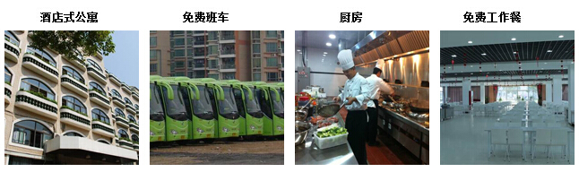

Free Employee Meals

Kitchen

Free Shuttle Bus

Serviced Apartment tric Co., Ltd.

To care for the disabled employees, the Party committee and labor union of Siyuan Electric organized employee care activities, presented them with the gift packages for the Spring Festival, helped the employees in need solve material difficulties, encouraged them to keep self-improvement, learn to be gratitude, and give back to society.

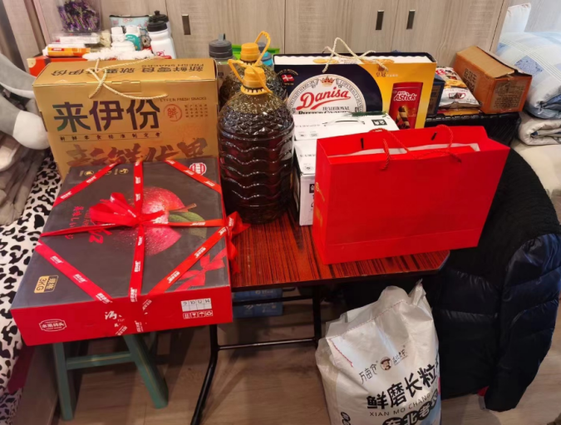

**Holiday Condolences for Special Groups of Employees**

### 5.3.2 Democratic Management

Sieyuan Electric actively builds an open, transparent and democratic communication mechanism, and respects employees' freedom of association. In accordance with the provisions of the *Labor Union Law of the People's Republic of China* and the *Constitution of the Chinese Trade Union*, the Company organizes and re-elects the trade union organizations, and clarifies that employees may voluntarily join the labor union organization. In 2023, all employees signed the collective bargaining agreement.

The Company has established diverse and smooth communication channels, enabling employees to completely express or put forward their demands congress of workers and staff, satisfaction survey and other ways. The Company can understand the aspirations of employees, find the shortcomings in management and work, and constantly bridge the gap by analyzing the causes and formulating action plans, so as to create a good working atmosphere. We randomly select 10% to 20% of employees each month to participate in surveys on catering satisfaction, administrative satisfaction, IT satisfaction, and onboarding satisfaction. Then we collect, analyze, discuss and summarize the survey results into a satisfaction survey report, and formulate and implement improvement plans to improve their satisfaction.

In addition, we hold two engagement surveys per year, and summarize the data based on the results for the reference of subsidiaries, and prepare a special improvement plan for the engagement survey. Through this initiative, the Company can gain a more comprehensive understanding of employees' work attitudes and satisfaction, identify problems in time, and take targeted measures to further enhance their work enthusiasm and organizational cohesion.

### 5.3.3 Employee Activities

Sieyuan Electric attaches great importance to the physical and mental health of employees and continuously enriches their leisure activities. During the reporting period, the Company actively organized a variety of corporate cultural activities such as sports games, birthday parties, and blind dates to help employees balance their work and life, allowing them to work happily and live healthily, and creating a harmonious working atmosphere for them.

**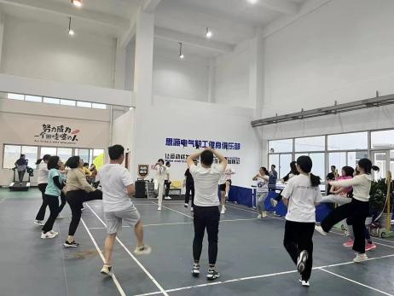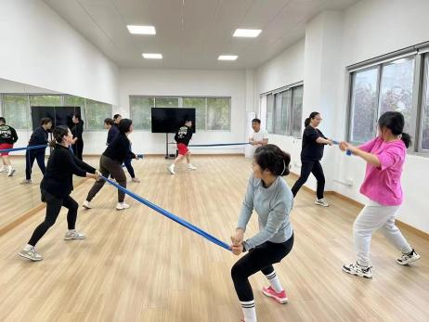**

**Fitness Club**

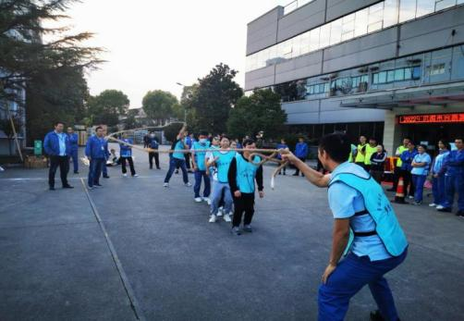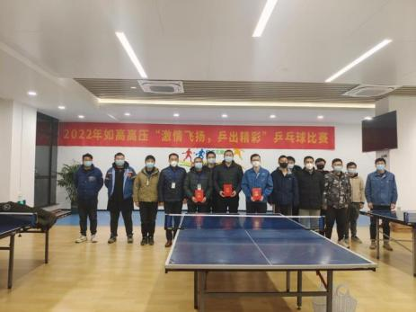

**Sports Games Table Tennis Match**

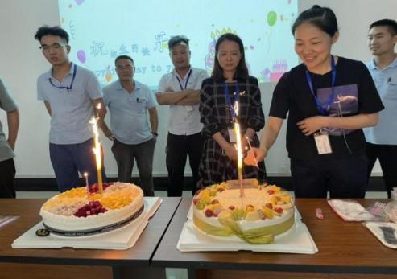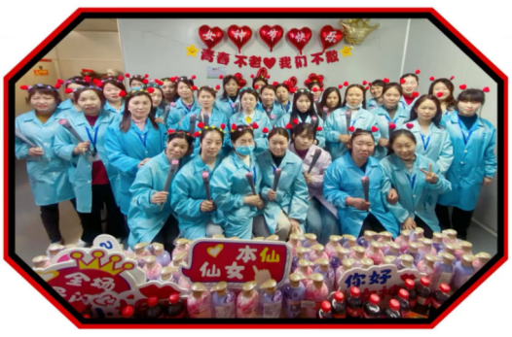

**Employee Birthday Party Women's Day Celebration**

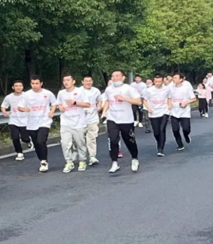**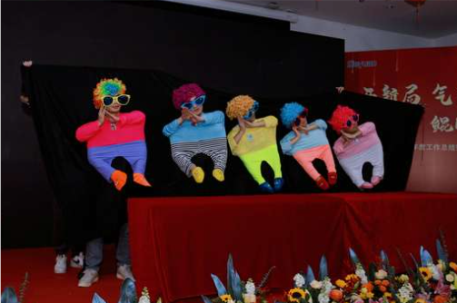**

**Running Exercise Artistic Performance**

|  |
| --- |
| **Case Study] Sieyuan | “I Participate, I’m Healthy and I’m Happy” 1-hour Lunchtime Sports Tournament**  Exercise is the best way to enhance human immunity. In order to help employees develop healthy habits, we actively participated in the “I Participate, I’m Healthy and I’m Happy” 1-hour Lunchtime Sports Tournament organized by the Federation of Labor Unions of Shenzhuang Industry Park in 2023. This event allowed employees to participate in healthy and fun activities during lunch breaks, establish a healthy and healthy lifestyle which was beneficial to physical and mental health, and further stimulated their enthusiasm and vitality in work and study.  IMG_256 |

## 5.4. Employee Development

Sieyuan Electric focuses on employee training and development, and establishes and continuously improves a hierarchical training and talent development system (four levels: group, system, business unit and department) to develop a smooth development path for employees, help them continuously improve themselves, realize their self-actualization, and work together to realize the sustainable development of the Company.

### 5.4.1 Employee Training

Based on the strategies and business needs, the Company continuously deepens the optimization and certification of qualification standards, and improves and optimizes the curriculum and teaching material system. For employees at different levels and positions, we have implemented talent development projects and training programs at different levels, focusing on cultivating high-quality talents such as technical businessmen, engineering businessmen and Sieyuan craftsmen.

In terms of training management, we have vigorously developed and utilized online training platforms and resources, effectively engaging employees in overseas offices around the world, and improving the timeliness and coverage of training. This initiative not only helps employees to learn regardless of time and geography, but also provides them with a more flexible and efficient way to learn, promoting their personal growth and organizational development. During the reporting period, 100% of employees were trained on vocational skills in Sieyuan Electric.

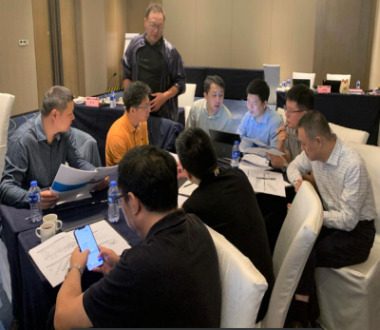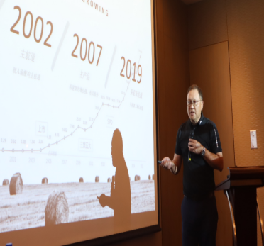

**Employee Skills Training Site**

**Employee Training Data**

|  |  |  |  |  |
| --- | --- | --- | --- | --- |
| **Indicator** | **Unit** | **2023** | **2022** | **2021** |
| Total investment in training | RMB 10,000 | 620.0 | 525.2 | 466.6 |
| Number of employees receiving training | Person | 39288.0 | 35700.0 | 32767.0 |
| Number of training sessions | Time | 1316.0 | 1371.0 | 1283.0 |
| Total training hours | Hour | 98220.0 | 76840.0 | 64150.0 |
| Average training hours per employee | Hour | 12.5 | 11.5 | 10.6 |

### 5.4.2 Career Development

Adhering to the principle that "employees are the protagonists of the Company and the Company is the stage for employees", Sieyuan Electric constantly improves the compensation and incentive mechanisms, and provides employees with a variety of development channels. It implements a "dual-channel" promotion system, including technical/business promotion sequence and management promotion sequence, providing a path for the employees in different positions to realize sustainable development. The employees in the position of chief expert of technical channel can enjoy the same treatment as that of the Company's senior executive s. During the reporting period, 100% of employees were evaluated for their performance and career development.

The Company has developed equity incentive plan, employee stock ownership plan and other employee incentives, and provides employees with multiple reward mechanisms such as year-end double pay, performance bonus, profit sharing, and equity incentive. These incentives are designed to motivate employees' enthusiasm and creativity, and enable excellent talents to stand out.

## 5.5 Occupational Health and Safety

It is one of important symbol of the people-oriented approach to pay attention to and safeguard employees’ occupational health and safety. Sieyuan Electric attaches great importance to and constantly strengthens the occupational health and safety of employees.

### 5.5.1 Workplace Safety

In Sieyuan Electric, we adhere to the policy of "safety first, prevention oriented, comprehensive management", and strictly abide by the *Workplace Safety Law of the People’s Republic of China* and other laws and regulations. We always put the safety of employees in the first place, assume the main corporation responsibility, and strictly fulfill the legal responsibility for workplace safety. The Company and its subsidiaries have set up safety committee. The director of the safety committee is the chairman of the board and the main persons in charge of the subsidiaries, and the members are department heads, employee representatives and union members. The safety committee holds a quarterly meeting to discuss the Company's safety issues, compliance management with national laws, regulations and departmental rules, the four non-exemptions for workplace incidents, and the control of major hazards.

The Company and its subsidiaries have set up safety committee. The director of the safety committee is the chairman of the board and the main persons in charge of the subsidiaries, and the members are department heads, employee representatives and union members. The safety committee holds a quarterly meeting to discuss the Company's safety issues, compliance management, workplace incident handling, and control of major hazards.

The main persons in charge of the subsidiaries and the management cadres at all levels conduct regular inspections on environmental and safety risks of all operating sites in accordance with the safety inspection system, and require the person in charge of responsible area to rectify the safety hazards found in a closed-loop way. The main persons in charge personally rectify the major safety hazards. The Company appoints employee representatives to participate in safety management, including hazard identification, control measures review and safety incident investigation.

The Company employs a third party to provide laws, regulations, rules, and standards to ensure its safety management system is compliant and adaptable, revise the safety management system every year, and conduct a major review every three years, to strengthen the construction of workplace safety systems and effectively enhance the fairness and seriousness of safety supervision and management.

We provide three-level safety training to new employees, and only those who pass the exam can take up their positions. The main persons in charge and safety management staff are required to obtain license before taking up their positions. Every year, we sign a safety responsibility agreement with employees, and establish a safety management responsibility network where employees take dual responsibilities, horizontally to the edge and vertically to the end.

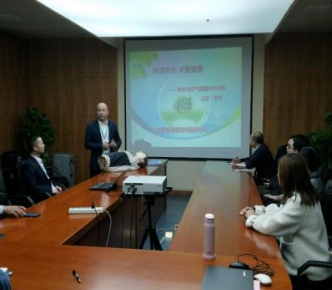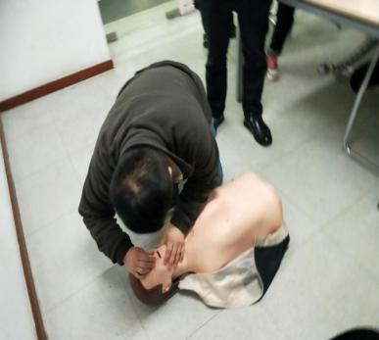

**On-site Popularization of Safety Education and Training**

In terms of emergency response, we formulate and implement the *Management Procedures for Emergency Control* and the *Comprehensive Plan for Workplace Safety Incidents* in accordance with the provisions of national workplace safety laws and regulations. We also establish the emergency response procedures, stipulating the provisions for on-site emergency response, prompt reporting, coordination and interaction, information disclosure, investigation and treatment of emergencies. We regularly conduct emergency drills, aiming to enable employees to further understand the emergency response process, test the soundness and practicality of emergency rescue plans, and accumulate experience for rapid, orderly and efficient response to emergencies.

**Workplace Safety Data**

|  |  |  |  |  |
| --- | --- | --- | --- | --- |
| **Indicator** | **Unit** | **2023** | **2022** | **2021** |
| Investment in workplace safety | RMB 10,000 | 1,134 | 1,050 | 958 |
| **Employment Injury Data** | | | | |
| Number of employee fatalities | Person | 0 | 0 | 0 |
| Number of attempted incidents | Nos. | 15 | 10 | 12 |
| Lost workdays due to work-related injuries | Nos. | 5 | 2 | 3 |
| Number of lost workdays due to work-related injuries | Day | 317 | 226 | 256 |
| Rate of severe incidents that cause loss of working hours of direct labor (workdays lost by injury) x (1,000/ total working hours) | / | 0.0 | 0 | 0.02 |
| Number of recordable incidents | Nos. | 18 | 12 | 15 |
| Rate of incidents that cause loss of working hours of direct labor (number of injury incidents causing loss of working hours x 1,000,000 / total working hours) | / | 1 | 1 | 1 |
| Total Work Hours | Work Hours | 15,664,000 | 13,368,000 | 12,198,000 |

### 5.5.2 Occupational Health

In order to strengthen the management of occupational disease prevention and control, improve the level of occupational disease prevention and control, and effectively protect the health and safety of workers in the work process, Sieyuan Electric has continuously improved and conscientiously implemented the occupational health management regimes and established a comprehensive and perfect occupational health and safety system in accordance with relevant national policies, laws and regulations on occupational health such as the *Workplace Safety Law of the People’s Republic of China*, the *Occupational Disease Prevention and Control Law of the People’s Republic of China*, the *Regulation on Work-Related Injury Insurances*, and the *Regulations on Labor Protection in Workplaces Where Toxic Substances Are Used*.

**Sieyuan Electric’s Subsidiaries Passing the Occupational Health and Safety System Certification enterprise**

|  |  |  |  |  |  |  |
| --- | --- | --- | --- | --- | --- | --- |
| S/N | Enterprise Names | Business Type | Certification Awarded | Certificate No. | Date of Initial Issue | Validity Period |
| 1 | Sieyuan Electric Co., Ltd. | Manufacturing | Yes | OHS 662497 | 2016/12/7 | 2025/12/6 |
| 2 | Shanghai Sieyuan High Voltage Switchgear Co., Ltd. | Manufacturing | Yes | OHS 662502 | 2016/12/7 | 2025/12/6 |
| 3 | Jiangsu Rugao High Voltage Electrical Appliance Co., Ltd. | Manufacturing | Yes | OHS 660811 | 2019/9/25 | 2025/10/9 |
| 4 | Shanghai Sieyuan Optoelectronics Co., Ltd. | Manufacturing | Yes | OHS 731417 | 2020/9/15 | 2023/9/14 |
| 5 | Jiangsu Sieyuan Hertz Instrument Transformer Co., Ltd. | Manufacturing | Yes | OHS 661557 | 2019/10/16 | 2025/11/6 |
| 6 | Shanghai Sieyuan Power Capacitor Co., Ltd. | Manufacturing | Yes | OHS 660782 | 2019/10/9 | 2025/10/31 |
| 7 | Shanghai Sieyuan Hongrui Automation Co., Ltd. | Production | Yes | OHS 661846 | 2019/11/2 | 2025/11/1 |
| 8 | Sieyuan Qingneng Electrical & Electronic Co., Ltd. | Production | Yes | OHS 658934 | 2019/8/20 | 2025/8/22 |
| 9 | Changzhou Sieyuan Toshiba Transformer Co., Ltd. | Manufacturing | Yes | 02120S10484R3M | 2020/8/7 | 2023/8/6 |
| 10 | Jiangsu Sieyuan Medium Voltage Switchgear Co., Ltd. | Manufacturing | Yes | 21179S10185ROM | 2021/8/20 | 2024/8/19 |
| 11 | Shanghai Sieyuan Power Transmission and Distribution Engineering Co., Ltd. | Manufacturing | Yes | 0422S10461R0M | 2022/12/1 | 2025/11/30 |
| 12 | Shanghai Timi Automotive Technology Co., Ltd. | Manufacturing | Yes | OHS 711063 | 2019/6/24 | 2025/6/23 |
| 13 | GMCC Electronic Technology Wuxi Co., Ltd. | Production | Yes | 04623S10656R1M | 2020/1/21 | 2026/1/17 |

The Company takes active steps to create a safe production environment to safeguard employees’ lives and properties. Every year, we commission professional testing institutions to test major occupational disease hazard factors in production sites, including dust, harmful chemicals, noise, and high temperature.

For the positions with occupational health and safety risks, we strictly follows the *Code of Practice for Selection of Personal Protective Equipments* (GB/T11651-2008) and the *Management Specification for Labor Supplies of Employers*, provide the operators exposed to occupational disease hazards, such as dust, harmful chemicals, noise, and high temperatures, with conforming and effective personal protective equipment, and guide and supervise them in the correct use of such equipment. Moreover, we regularly organize employee physical examinations every year, with a coverage rate of 100% for physical examinations and health files. During the reporting period, there was no occupational disease, and the incidence rate of occupational diseases was 0%.

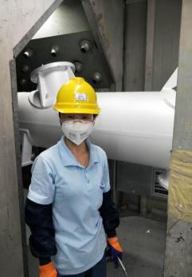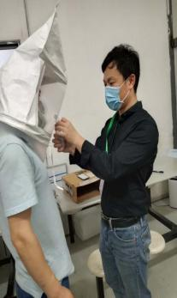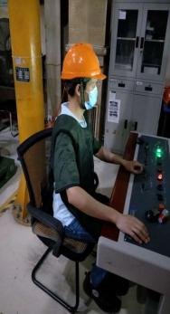

**PPE Inspection Radiation-proof Clothing Protection**

|  |  |  |  |  |
| --- | --- | --- | --- | --- |
| **Occupational Disease Data** | | | | |
| Number of employees undergone occupational health examinations | Person | 445 | 377 | 325 |
| Number of employees diagnosed with occupational diseases | Person | 0 | 0 | 0 |
| Number of employees diagnosed with occupational contraindications | Person | - | - | - |
| Coverage Rate of Employee Physical Exam (for positions with occupational hazards) | Person | 100% | 100% | 100% |

# 6. Low-carbon Operation to Practice Environmental Protection

Strictly complying with laws, regulations and relevant industry requirements, Sieyuan Electric continuously improves its management system of energy conservation and consumption reduction, tries its best to minimize operational impact on the environment, and actively optimizes the efficiency of its equipment, so as to reduce the its greenhouse gas emissions. In 2022, Sieyuan Electric Co., Ltd. responded for the first time to the international CDP (Carbon Disclosure Project) platform and obtained reports and results.

## 6.1 Environmental System Construction

It is a responsibility incumbent on every citizen to protect the ecological environment. Sieyuan Electric attaches great importance to environmental protection, and takes low carbon emission, environmental protection and sustainability as the first responsibility in corporate development. It integrates them into every aspect and business of the Group's operation. It is committed to creating first-class business performance while continuously improving environmental management, promoting green culture, achieving pollution prevention, accident prevention and continuous improvement, and continuously improve the environmental management performance of the Company.

The Company and its subsidiaries have established a sound environmental management system, identified and assessed environmental risks regularly every year, and invited third-party organizations to audit and certify the operation of the working environment management system. During the reporting period, the Company and its subsidiaries passed the certification of IS014001 system.

**List of Sieyuan Electric’s Subsidiaries Passing Environmental System Certification**

|  |  |  |  |  |  |  |
| --- | --- | --- | --- | --- | --- | --- |
| S/N | Enterprise Names | Business Type | Certification Awarded | Certificate No. | Date of Initial Issue | Expiry Date |
| 1 | Sieyuan Electric Co., Ltd. | Manufacturing | Yes | EMS 662495 | 2016/12/7 | 2025/12/6 |
| 2 | Shanghai Sieyuan High Voltage Switchgear Co., Ltd. | Manufacturing | Yes | EMS 662500 | 2016/12/7 | 2025/12/6 |
| 3 | Jiangsu Rugao High Voltage Electrical Appliance Co., Ltd. | Manufacturing | Yes | EMS 660808 | 2016/10/10 | 2025/10/9 |
| 4 | Shanghai Sieyuan Optoelectronics Co., Ltd. | Manufacturing | Yes | EMS 731416 | 2020/9/15 | 2023/9/14 |
| 5 | Jiangsu Sieyuan Hertz Instrument Transformer Co., Ltd. | Manufacturing | Yes | EMS 661555 | 2016/11/7 | 2025/11/6 |
| 6 | Shanghai Sieyuan Power Capacitor Co., Ltd. | Manufacturing | Yes | EMS 660778 | 2016/11/1 | 2025/10/31 |
| 7 | Shanghai Sieyuan Hongrui Automation Co., Ltd. | Manufacturing | Yes | EMS 661844 | 2016/11/2 | 2025/11/1 |
| 8 | Sieyuan Qingneng Electrical & Electronic Co., Ltd. | Manufacturing | Yes | EMS 658931 | 2016/8/23 | 2025/8/22 |
| 9 | Changzhou Sieyuan Toshiba Transformer Co., Ltd. | Manufacturing | Yes | U006622E0165R6M | 2022/9/2 | 2025/9/1 |
| 10 | Jiangsu Sieyuan Medium Voltage Switchgear Co., Ltd. | Manufacturing | Yes | 21179E10185ROM | 2021/8/20 | 2024/8/19 |
| 11 | Shanghai Sieyuan Power Transmission and Distribution Engineering Co., Ltd. | Manufacturing | Yes | 0422E10460R0M | 2022/12/1 | 2025/11/30 |
| 12 | Shanghai Timi Automotive Technology Co., Ltd. | Manufacturing | Yes | EMS 711059 | 2019/6/24 | 2025/6/23 |
| 13 | GMCC Electronic Technology Wuxi Co., Ltd. | Manufacturing | Yes | 04623E10660R1M | 2020/1/21 | 2026/1/17 |

### 6.1.1 Environmental Protection Training

Sieyuan Electric lays stress on the cultivation and publicity of environmental protection concepts among employees, and trains new employees on EHS knowledge to strengthen their awareness of environmental protection. The Party committee and labor union call on employees to respond to the government's relevant environmental protection policies and actions, and publicizes and reports the contents and activities on environmental protection in the internal publication *Sieyuan People* to enhance employees' environmental awareness. During the reporting period, all employees underwent EHS training courses.

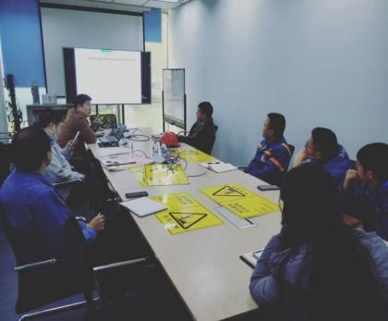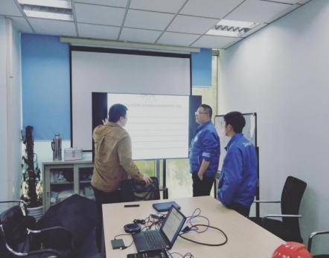

**Training on Environmental Protection Knowledge**

### 6.1.2 Environmental Emergency Response

The Company keeps a watchful eye on the prevention and response of environmental emergencies, aiming to improving the environmental emergency response capability of all employees. In order to effectively prevent, immediately control and eliminate the associated/secondary pollution generated in the incident management, and standardize the emergency management of environmental pollution, Sieyuan Electric has formulated emergency plans for environmental incidents, emergency drill plans for hazardous waste, etc., clarifying the responsibilities and tasks of the relevant departments in the process of incident treatment. We organize emergency drills every year to improve the emergency response speed and cooperative operation capability in case of environmental pollution incidents, so as to protect the life safety and health of employees and the public, minimize environmental risks, protect the ecological environment, and promote the sustainable development of the Company.

## 6.2 Energy Conservation and Consumption Reduction

Sieyuan Electric strengthens energy management monitoring, establishes and improves an energy management system, clarifies energy assessment indicators and energy consumption evaluation, and continuously performs energy efficiency testing and evaluation. Moreover, we increase the investment in environmental protection, and integrate automation, informatization and project management, demonstrating the operation and maintenance concept of "green factory".

In terms of equipment and facilities, we use new energy-saving products such as motors with energy efficiency not lower than Level 2, inverter-fed motors, and energy-saving lamps. According to the actual production load, power-factor compensator is adopted for the power consumption in the projects, and the terminal power compensation device is used to reduce the reactive power loss. With a visual energy monitoring system, we can monitor the energy consumption of key equipment in real time and analyze the dynamic current of equipment to reduce energy waste and maximize the utilization of baseline power.

In addition, the plants are constructed with new eco-friendly and energy-saving insulation materials. It is planned to use PV power facilities in new projects. For the air-conditioning system, new eco-friendly refrigerants at European and American standards are used to reduce energy consumption.

|  |  |  |  |  |
| --- | --- | --- | --- | --- |
| **Water Consumption Data** | | | | |
| **Indicator** | **Unit** | **2023** | **2022** | **2021** |
| Total water consumption | Ton | 270,200 | 220,877 | 196,309 |
| Tap water | Ton | 270,200 | 220,877 | 196,309 |
| Recycled water amount | Ton | 86,472 | 98,760 | 36,336 |
| Water recycling rate | % | 32 | 44.7 | 18.5 |
| Water consumption per unit of output value | Tons of water/RMB 10,000 | 0.215 | 0.21 | 0.226 |
| Total wastewater discharged | Ton | 8,683 | 24,690 | 10,174 |

**Energy Consumption Data**

|  |  |  |  |  |  |
| --- | --- | --- | --- | --- | --- |
| **Indicator** | | **Unit** | **2023** | **2022** | **2021** |
| Direct energy (Scope 1) | Natural gas | m3 | 849,510 | 1,278,264 | 1,134,450 |
| Diesel oil | Liter | 27,693 | 19,826 | 21,200 |
| Gasoline | Liter | 7,854 | 6,889 | 7,683 |
| Indirect energy (Scope 2) | Purchased electricity | kWh | 64,189,300 | 53,008,800 | 51,604,502 |
| PV power generation | kWh | 849,510 |  |  |
| Purchased steam | Ton | - | 3,685 | 4,058 |

**GHG Emission Data**

|  |  |  |  |  |
| --- | --- | --- | --- | --- |
| **Indicator** | **Unit** | **2023** | **2022** | **2021** |
| Total GHG emissions | tCO2e | 266937 | 60141.62 | 49262.16 |
| – Direct GHG emissions (Scope 1) | tCO2e | 1,744 | 781.96 | 2543.22 |
| – Indirect GHG emissions (Scope 2) | tCO2e | 45,157 | 30895.63 | 29983.46 |
| – Indirect GHG emissions (Scope 3) | tCO2e | / | 27464.0293 | 16735.48 |

## 6.3 Pollution Reduction and Efficiency Enhancement

Sieyuan Electric continues to take efforts to further reduce the generation of wastewater, exhaust gas and hazardous solid waste through control and modification of technological processes, management and equipment. For example, we combine the pre-electroplating processing lines, use air energy instead of steam, utilize waste heat recovered from air compressors to heat the electroplating line, and improve the efficiency of natural gas combustion during mold baking.

The Company innovates in the process flow, discharges the production wastewater by self-built wastewater treatment system, and realizes the reuse of reclaimed water. We use clean natural gas instead of traditional oil fuel in the production process, optimize the technological processes, and reduce the grinding and other steps, reducing dust generated from cutting and polishing. In addition, some exhaust gases are treated by adsorption devices, activated carbon and professional VOC devices.

In order to ensure environmental quality, the Company entrusts third-party organizations to conduct regular environmental monitoring, ensuring that wastewater, exhaust gas and noise comply with relevant standards. The hazardous waste generated by the Company are registered and recorded online by the government and handled by qualified third-party companies in a coordinated manner.

|  |  |  |  |  |
| --- | --- | --- | --- | --- |
| **Water Pollutant Discharge Data** | | | | |
| Total amount of water pollutant discharged | Ton | 23.42 | 46.59 | 19.20 |
| COD | Ton | 12.47 | 9.88 | 4.07 |
| Ammonia nitrogen | Ton | 0.86 | 0.49 | 0.20 |
| Suspension substance | Ton | 2.21 | 0.25 | 0.10 |
| Total arsenic | Ton |  | 0.00 | 0.00 |
| **General Waste Data** | | | | |
| Total general waste generated (including total amount of non-hazardous waste) | Ton | 537.97 | 416.10 | 274.58 |
| General waste treated | Ton | 537 | 416.10 | 274.58 |
| **Hazardous Waste Data** | | | | |
| Total hazardous waste generated | Ton | 702.38 | 491.01 | 324.14 |
| Hazardous waste transferred | Ton | 702.38 | 491.01 | 324.14 |
| **Exhaust Emission Data** | | | | |
| Total exhaust emissions | Ton | 0.85 | 0.05 | 0.05 |

## 6.4 Green Operation

The Company actively fulfills its corporate social responsibility and constantly strives to minimize the environmental impact of its operations, with the goal of promoting sustainable development.

### 6.4.1 Green Office

We actively integrate the new concept of low-carbon office, gradually develop and enhance employees' awareness of energy conservation and environmental protection, actively promote the green office program, advocate all employees to practice a new low-carbon lifestyle, and strive to create a green and sustainable corporate culture.

In the Company, we set up billboards to remind employees to use energy-saving LED lights and implement the principle of “turning on lights only in need"; make an effort to improve waste sorting; try to use water-saving sanitary ware as much as possible to reduce water consumption; give priority to recycled products or fast-growing forest wood products when purchasing printing paper, and minimize the printing amount, so as to achieve green and environmentally friendly office. The Company implements digital workflows to promote paperless operations, resulting in a large reduction in paper documents, printing, paper consumption and other office costs. We leverage internal email system for document circulation and communication, saving the postage, traveling expenses, communication expenses and manpower required for sending paper documents, thus effectively improving office efficiency and saving a lot of office expenses.

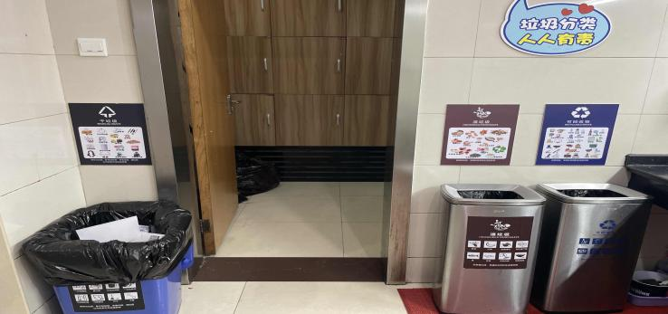

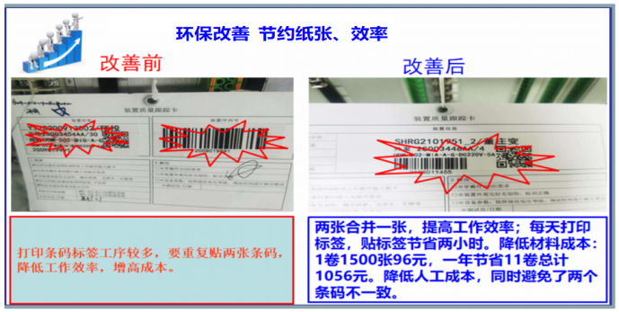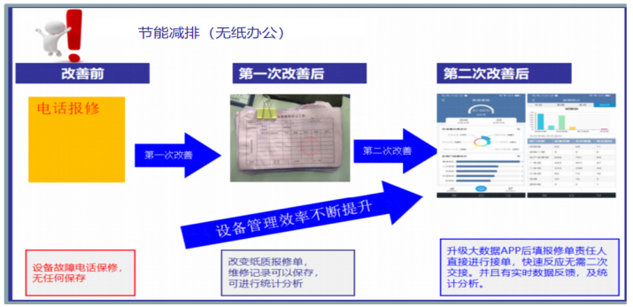

### 6.4.2 Green Travel

To promote sustainability and reduce carbon emissions, we actively encourage green travel among our employees, provide shuttle service for them and encourage them to use new energy vehicles. We also set charging piles in the factory to facilitate them to use electric vehicles. The initiatives are to reduce the carbon footprint of the Company and employees and lower the environmental impact. We believe that these green transportation options and convenient charging facilities can motivate employees to adopt greener travel ways.

By using shuttle buses and new energy vehicles, we help employees reduce the frequency of personal vehicle use, reducing road congestion and traffic pollution. In addition, the installation of charging piles is not only convenient for employees, but also provides them with more opportunities to use electric vehicles.

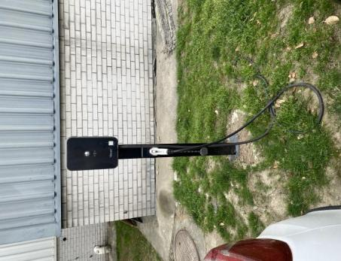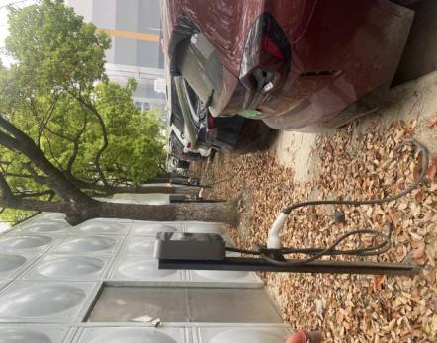

**Charging Piles in the Park**

### 6.4.3 Green Transport

We improve the transfer tools, enhance the standardization of logistics equipment, change transportation methods, and improve the loading capacity of transport vehicles, reducing the transport costs of our products. Centralized shipping is adopted to increase the number of vehicles used. Our products are directly transported from the factory to the construction site, reducing vehicle transfer and intermediate logistics links. Export products are transported in containers, reducing operational links in the logistics process, improving logistics efficiency, and achieving green logistics.

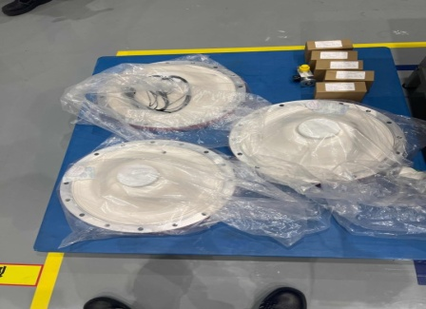

**Before improvement: unpack, use electric forklift to pick up the pallets, and send them to the workshop**

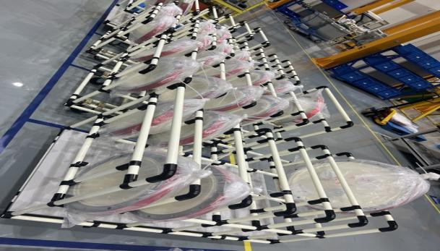

**After improvement: Use a wheeled wire-rod shelves instead of forklift to improve transfer efficiency and save forklift power consumption.**

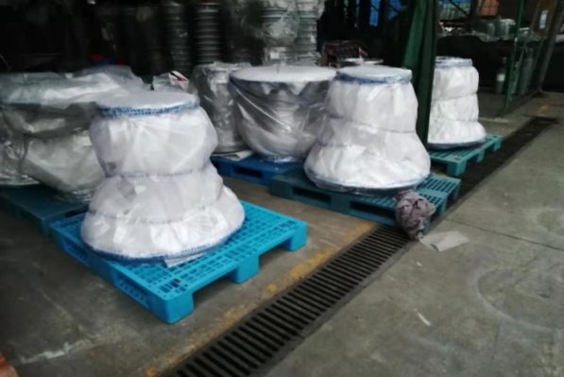

**Before improvement: Large space occupied by shell storage**

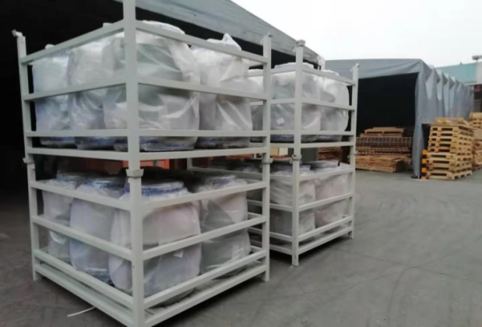

**After improvement: Store products in iron cages, effectively utilizing space**

### 6.4.3 Green and Intelligent Manufacturing

Sieyuan Electric incorporates the carbon peak and neutrality targets into the development planning, gradually implements the digital operation tools throughout the process, and promotes the interconnectivity a product, equipment and factory level in the construction of each new manufacturing base. This practice makes production, inventory data, equipment status, personnel status, and energy situation transparent and visible, and enables information exchange between departments and levels. We gradually move towards green and intelligent manufacturing by improving management and energy efficiency.

Furthermore, we actively utilize new technologies, such as digital, information-based, lean and intelligent means, to optimize the early design and continuously enhance the later operation. We strive to realize the goal of “green factory” from the four dimensions: safety, efficiency, intelligence and green. To meet the diverse needs for flexible expansion, rapid replication, and remote management, we also put efforts into energy conservation, emission reduction, efficiency improvement, quality assurance, and circular sustainability.

# 7. Responsibility Bearing to Contribute to Society

Sieyuan Electric actively shoulders corporate social responsibility, promotes the development of future talents, and cares about and supports public welfare undertakings by means of education supporting, voluntary blood donation, poverty alleviation, employment of the disabled, volunteer service and other public welfare activities.

## 7.1 Educational Support

Sieyuan Electric has always been concerned about education, and strives to improving the learning and living environment of poverty students by various charitable donations and voluntary activities, and effectively helping the coordinated development of primary-level cultural undertakings and regional education.

Since 2007, the Company has set up "Sieyuan Electric Scholarship" at Huazhong University of Science and Technology for 16 consecutive years. Up to now, we have donated RMB 4.3 million to this university, subsidizing more than 1,300 students. In the future, Sieyuan Electric will continue to support the education of the college and cultivate more talents in the power field.

In addition, in order to effectively promote university-enterprise cooperation and motivate all students to study hard, Sieyuan Electric set up a "Sieyuan Electric Scholarship", totaling RMB 1 million, in Northeast Electric Power University in 2011. So far, we have subsidized more than 180 students.

Though winter is coming, we still have undying passion. In mid-December 2023, the Public Welfare Group and the domestic marketing representatives in Guangxi of Sieyuan Electric visited the Second Primary School in Tongle Miao Township, Sanjiang County, Guangxi Province, 1,557 kilometers away. They donated RMB 300,000 to the school on behalf of all employees of Sieyuan, as well as a life-saving fire stairway, 700 sets of new double-column desks and chairs, 880 trendy and exquisite backpacks, 100 pairs of DHS badminton rackets, 1,000 badmintons, 2 sets of badminton and air volleyball stands, and 80 Li-Ning basketballs.

IMG_256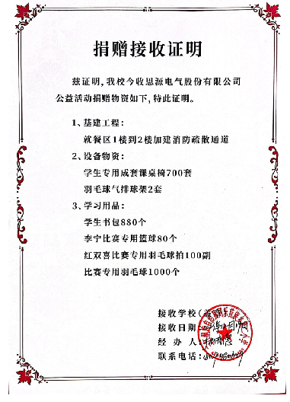

**Donation Ceremony of Sieyuan Electric**

## 7.2 Public Welfare Activities

Running for nine years, we always head towards new goals. From 2015 to 2023, the nine-year "Love • Run" is an enduring process witnessing the development and progress of public welfare undertakings, bringing hope and warmth to more people. November 4, 2023

The Ninth “Love • Run” Public Welfare Activities were held as scheduled in Sieyuan Electric, with 4,003 participants and a running distance of 18,001.2 kilometers. More than RMB 300,000 donation was raised in this event. In the cold winter, the vitality and enthusiasm of Sieyuan staff brought warm to the people in hardship.

**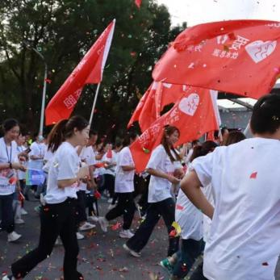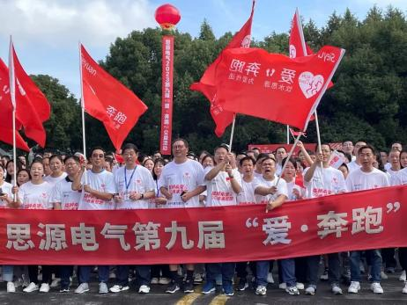**

**The Ninth “Love • Run” Public Welfare Activities of Sieyuan Electric**

# 8. GRI Indicator Index

|  |  |  |  |
| --- | --- | --- | --- |
| **Statement of Use** | Sieyuan Electric Co., Ltd. has reported the information cited in this GRI content index for the period from January 1, 2023, to December 31, 2023 with reference to the GRI Standards. | | |
| **GRI 1 used** | GRI 1: Foundation 2021 | | |
| **GRI Standards** | Disclosures | Corresponding Position | Reason for Omission |
| The organization and its reporting practices | 2-1 Organizational details | Company Overview |  |
| 2-2 Entities included in the organization’s sustainability reporting | Reporting Boundary |  |
| 2-3 Reporting period, frequency and contact point | About the Report |  |
| Restatements of information | / | No information restated |
| 2-5 External assurance | / |  |
| Activities and workers | 2-6 Activities, value chain and other business relationships | Company Overview  Product Quality  Customer Services  Sustainable Supply Chain |  |
| 2-7 Employees | Staffing Overview |  |
| 2-8 Workers who are not employees | / | N/A |
| Governance | 2-9 Governance structure and composition | Governance Structure |  |
| 2-10 Nomination and selection of the highest governance body | Governance Structure |  |
| 2-11 Chair of the highest governance body | Governance Structure |  |
| 2-12 Role of the highest governance body in overseeing the management of impacts | Governance Structure  Analysis of Material Topics |  |
| 2-13 Delegation of responsibility for managing impacts | Governance Structure |  |
| 2-14 Role of the highest governance body in sustainability reporting | Analysis of Material Topics  About the Report |  |
| 2-15 Conflicts of interest | Governance Structure |  |
| 2-16 Communication of critical concerns | Social Responsibility Management  Analysis of Material Topics |  |
| 2-17 Collective knowledge of the highest governance body | Social Responsibility Management |  |
| 2-18 Evaluation of the performance of the highest governance body | Governance Structure |  |
| 2-19 Remuneration policies | / | Please refer to the Group's annual report |
| 2-20 Process to determine remuneration | / | Please refer to the Group's annual report |
| 2-21 Annual total compensation ratio | / | Please refer to the Group's annual report |
| Strategic, policies, and practices | 2-22 Statement on sustainable development strategy | Message from the Chairman |  |
| 2-23 Policy commitments | Business Ethics |  |
| 2-24 Embedding policy commitments | Business Ethics |  |
| 2-25 Processes to remediate negative impacts | Business Ethics |  |
| 2-26 Mechanisms for seeking advice and raising concerns | Business Ethics |  |
| 2-27 Compliance with laws and regulations | Please refer to the respective chapters of the report |  |
| 2-28 Membership associations | / |  |
| Stakeholder engagement | 2-29 Approach to stakeholder engagement | Communication with Stakeholders |  |
| 2-30 Collective bargaining agreements | Democratic Management |  |
| GRI 3: Material Topics 2021 | 3-1 Process to determine material topics | Analysis of Material Topics |  |
| 3-2 List of material topics | Analysis of Material Topics |  |
| 3-3 Management of material topics | Analysis of Material Topics |  |
| GRI 201: Economic Performance 2016 | 201-1 Direct economic value generated and distributed | Company Overview |  |
| 201-2 Financial implications and other risks and opportunities due to climate change | / |  |
| GRI 203: Indirect Economic Impacts 2016 | 203-1 Infrastructure investments and service supported | Responsibility Bearing to Contribute to Society |  |
| 203-2 Significant indirect economic impacts | Responsibility Bearing to Contribute to Society |  |
| GRI 205: Anti-corruption 2016 | 205-1 Operations assessed for risks related to corruption | Business Ethics |  |
| 205-2 Communication and training about anti-corruption policies and procedures | Business Ethics |  |
| 205-3 Confirmed incidents of corruption and actions taken | Business Ethics |  |
| GRI 206: Anti-competitive Behavior | 206-1 Legal actions for anti-competitive behavior, anti-trust, and monopoly practices | Business Ethics |  |
| GRI 302: Energy 2016 | 302-1 Energy consumption within the organization | Energy Conservation and Consumption Reduction |  |
| 302-2 Energy consumption outside of the organization | Energy Conservation and Consumption Reduction |  |
| 302-4 Reduction of energy consumption | Energy Conservation and Consumption Reduction |  |
| GRI 303: Water and Effluents 2018 | 303-1 Interactions with water as a shared resource | Energy Conservation and Consumption Reduction  Pollution Reduction and Efficiency Enhancement |  |
| Management of water discharge-related impacts | Energy Conservation and Consumption Reduction  Pollution Reduction and Efficiency Enhancement |  |
| 303-3 Water withdrawal | Energy Conservation and Consumption Reduction |  |
| 303-4 Water discharge | Energy Conservation and Consumption Reduction |  |
| 303-5 Water consumption | Energy Conservation and Consumption Reduction |  |
| GRI 305: Emissions 2016 | 305-1 Direct (Scope 1) GHG emission | Energy Conservation and Consumption Reduction |  |
| 305-2 Energy indirect (Scope 2) GHG emissions | Energy Conservation and Consumption Reduction |  |
| 305-3 Other indirect (Scope 3) GHG emissions | Energy Conservation and Consumption Reduction |  |
| 305-4 GHG emissions intensity | Energy Conservation and Consumption Reduction |  |
| 305-5 Reduction of GHG emissions | Energy Conservation and Consumption Reduction |  |
| GRI 306: Waste 2020 | 306-1 Waste generation and significant waste-related impacts | Pollution Reduction and Efficiency Enhancement |  |
| 306-2 Management of significant waste-related impacts | Pollution Reduction and Efficiency Enhancement |  |
| 306-3 Waste generated | Pollution Reduction and Efficiency Enhancement |  |
| 306-4 Waste diverted from disposal | Pollution Reduction and Efficiency Enhancement |  |
| 306-5 Waste directed to disposal | Pollution Reduction and Efficiency Enhancement |  |
| GRI 401: Employment 2016 | 401-1 Employee Hire Rate and Employee Turnover Rate | Compliant Employment |  |
| 401-2 Benefits provided to full-time employees that are not provided to temporary or part-time employees | Compensation and Benefits |  |
| 401-3 Parental leave | Employee Care |  |
| GRI 403: Occupational Health and Safety 2018 | Occupational health and safety management system | Workplace Safety  Occupational Health |  |
| 403-2 Hazard identification, risk assessment, and incident investigation | Workplace Safety  Occupational Health |  |
| 403-3 Occupational health services | Workplace Safety  Occupational Health |  |
| 403-4 Worker participation, consultation, and communication on occupational health and safety | Workplace Safety  Occupational Health |  |
| 403-5 Worker training on occupational health and safety | Workplace Safety  Occupational Health |  |
| 403-6 Promotion of worker health | Workplace Safety  Occupational Health |  |
| 403-7 Prevention and mitigation of occupational health and safety impacts directly linked by business relationships | Workplace Safety  Occupational Health |  |
| 403-8 Workers covered by an occupational health and safety management system | Workplace Safety  Occupational Health |  |
| 403-10 Work-related ill health | Workplace Safety  Occupational Health |  |
| GRI 404: Training and Education 2016 | 404-1 Average hours of training per year per employee | Employee Training |  |
| 404-2 Programs for upgrading employee skills and transition assistance programs | Career Development |  |
| 404-3 Percentage of employees receiving regular performance and career development reviews | Employee Training |  |
| GRI 405: Diversity and Equal Opportunity 2016 | 405-1 Diversity of governance bodies and employees | Compliant Employment |  |
| GRI 406: Non-discrimination 2016 | 406-1 Incidents of discrimination and corrective actions taken | Employees’ Rights and Benefits |  |
| GRI 408: Child Labor 2016 | 408-1 Operations and suppliers at significant risk for incidents of child labor | Compliant Employment  Employees’ Rights and Benefits |  |
| GRI 409: Forced or Compulsory Labor 2016 | 409-1 Operations and suppliers at significant risk for incidents of forces or compulsory labor | Employees’ Rights and Benefits |  |
| GRI 416: Customer Health and Safety 2016 | 416-1 Assessment of the health and safety impacts of product and service categories | Product Quality  Customer Services |  |
| 416-2 Incidents of non-compliance concerning the health and safety impacts of products and services | Product Quality  Customer Services |  |
| GRI 418: Customer Privacy 2016 | 418-1 Substantiated complaints concerning breaches of customer privacy and losses of customer data | Information Security and Privacy Protection |  |

# 9. SDGs Indicator Index

|  |  |
| --- | --- |
| **Sustainable Development Goals** | **Corresponding Chapters** |
| C_SDG_PRINT-01 | Message from the Chairman  Company Overview  Responsibility Bearing to Contribute to Society |
| C_SDG_PRINT-03 | Occupational Health  Occupational Health  Responsibility Bearing to Contribute to Society |
| C_SDG_PRINT-04 | Career Development  Educational Support |
| C_SDG_PRINT-05 | Staffing Overview  Employees’ Rights and Benefits |
| C_SDG_PRINT-06 | Occupational Health  Workplace Safety |
| C_SDG_PRINT-07 | Green and Intelligent Manufacturing  Pollution Reduction and Efficiency Enhancement |
| C_SDG_PRINT-08 | Employee Care |
| C_SDG_PRINT-09 | Company Overview  Innovation-driven Development  Public Welfare Activities |
| C_SDG_PRINT-10 | Fair Competition  Compliant Employment  Employees’ Rights and Benefits  Democratic Management |
| C_SDG_PRINT-11 | Message from the Chairman  EHS Policies  Sustainable Supply Chain  Industry Cooperation |
| C_SDG_PRINT-12 | Social Responsibility Management  Compliant Business Operation  Product Quality  Customer Services  Sustainable Supply Chain  Green and Intelligent Manufacturing  Green Office  Green Travel  Green Transport |
| C_SDG_PRINT-13 | Environmental System Construction  Pollution Reduction and Efficiency Enhancement |
| C_SDG_PRINT-14 | - |
| C_SDG_PRINT-15 | - |
| C_SDG_PRINT-16 | Message from the Chairman  Business Ethics  Fair Competition  Responsibility Bearing to Contribute to Society |
| C_SDG_PRINT-17 | Sustainable Procurement  Industry Cooperation  Communication with Stakeholders |